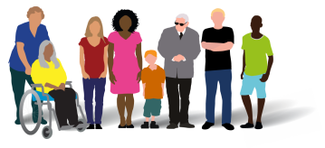

Eating Disorders Awareness Week 2022

  - Communications toolkit
February 2022

About the week
February 28-March 6 is Eating Disorder Awareness week.
Eating disorders are devastating mental illnesses that affect 1 in 50 people in the UK. Recovery is possible but spotting early warning signs, which may or may not be linked to a person’s weight or appearance, can be crucial.
To mark the week, Healthy London Partnership’s Mental Health Transformation and Children and Young People’s Mental Health teams have planned a week of activities to raise awareness around the symptoms and conditions of eating disorders.
We are sharing training and resources for healthcare and other professionals to recognise early symptoms, as well as support for the loved ones supporting children, young people and adults with eating disorders.
Visit HLP’s ED 2022 webpage to view our schedule of activities for the week. This page will be updated each day with new resources.

Eating disorders key information
- An eating disorder is a mental health condition where you use the control of food to cope with feelings and other situations.
- Around 1.25 million people in the UK suffer from these illnesses, many in secret.
- Unhealthy eating behaviours may include eating too much or too little or worrying about your weight or body shape.
- Anyone can get an eating disorder, but teenagers between 13 and 17 are mostly affected.
- The most common eating disorders are:
  - anorexia nervosa – trying to control your weight by not eating enough food, exercising too much, or doing both
  - bulimia – losing control over how much you eat and then taking drastic action to not put on weight
  - binge eating disorder (BED) – eating large portions of food until you feel uncomfortably full
  - Other specified feeding or eating disorder (OSFED) – a person may have an OSFED if their symptoms do not exactly fit the expected symptoms for any specific eating disorders. OSFED is the most common eating disorder. You can find out more about OSFED on the Beat website.
  - Avoidant/restrictive food intake disorder (ARFID) – ARFID is when someone avoids certain foods, limits how much they eat or does both.
- With treatment, most people can recover from an eating disorder.

Supporting Eating Disorders Awareness Week 2022 in London
This communications toolkit includes key information, social media assets to use on your own channels and links to further information, training material and guidance on eating disorders.

Content has been contributed by GPs, partner organisations and HLP’s teams, including blog and podcast content produced by the Transforming Mental Health programme’s Lived Experience Practitioners (LXPs) to highlight the patient voice and experiences of diagnosis, symptoms, physical and mental conditions, and recovery journey, from a range of eating disorders.

Over the course of the week, we are encouraging partners to share our assets and resources across your networks to help raise awareness and understanding around the complexities of eating disorders.

Get involved!
Please share this communications toolkit across your networks. You can also share your support on social media with our campaign assets.

Remember to tag us when sharing posts on social media:

Instagram: @healthy_ldn Facebook: @HealthyLDN Twitter: @HealthyLDN

LinkedIn: @Healthy London Partnership

Social media assets and suggested messaging
To download high quality images and videos: Right click the image and select ‘open link’ to download a full-size image to use across digital channels

Eating Disorders #1
Twitter | People with an #eatingdisorder aren't easily identifiable by extremely low body weight. People in ALL bodies have eating disorders, including anorexia and bulimia  Find resources including podcasts, blogs and advice to help a loved one with an eating disorder at  Healthy London Partnership or  Beat  @HealthyLDN @beatED | 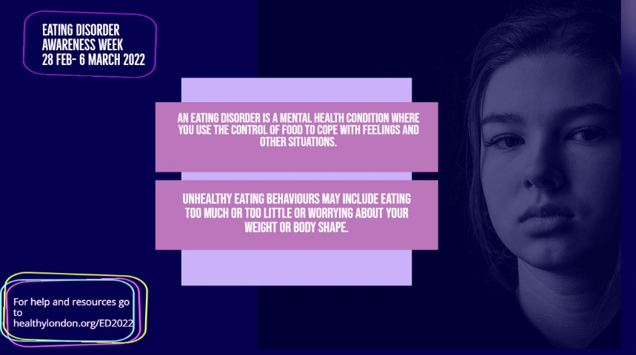
Facebook/LinkedIn | People with an #eatingdisorder aren't easily identifiable by extremely low body weight. People in ALL bodies have eating disorders, including anorexia and bulimia  Find resources including podcasts, blogs and advice to help a loved one with an eating disorder at Healthy London Partnership or  Beat | 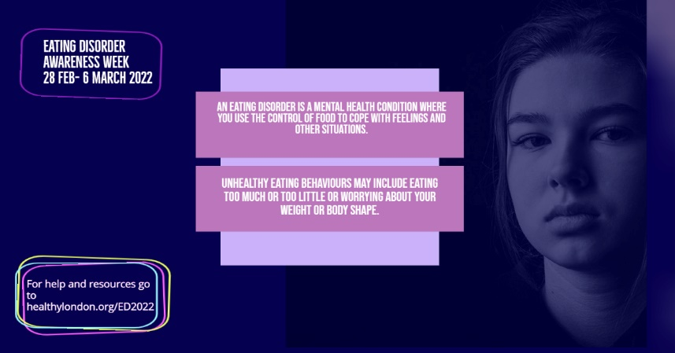
Instagram | People with an #eatingdisorder aren't easily identifiable by extremely low body weight. People in ALL bodies have eating disorders, including anorexia and bulimia  Find resources including podcasts, blogs and advice to help a loved one with an eating disorder at Healthy London Partnership or  Beat  @HealthyLDN @beatED | 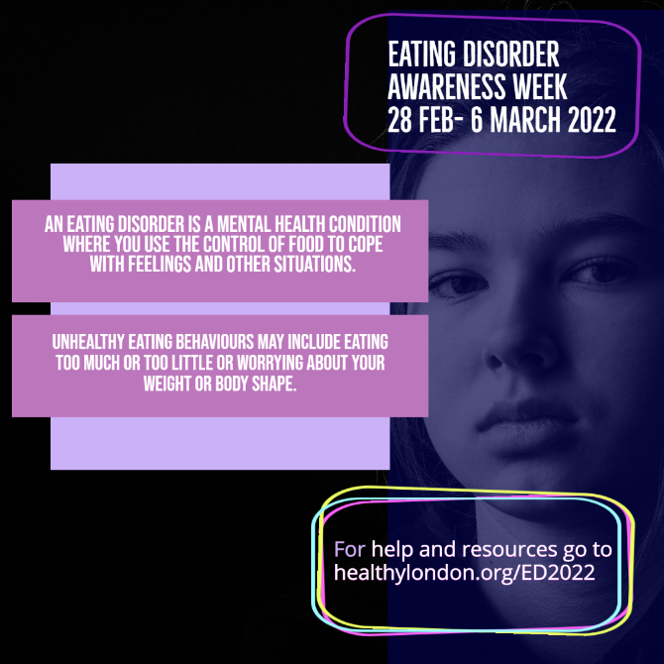

Eating Disorders secret
Twitter | You might not know who could be silently struggling with an #eating disorder.  Find resources including podcasts, blogs and advice to help a loved one with an eating disorder at Healthy London Partnership or  Beat  @HealthyLDN @beatED | 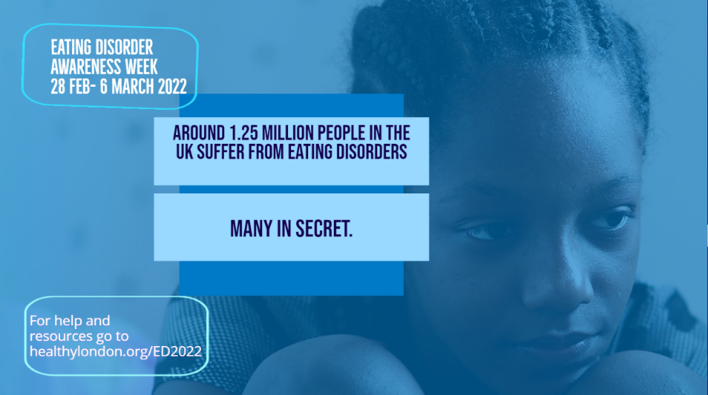
Facebook/LinkedIn | You might not know who could be silently struggling with an #eating disorder.  Find resources including podcasts, blogs and advice to help a loved one with an eating disorder at Healthy London Partnership or  Beat | 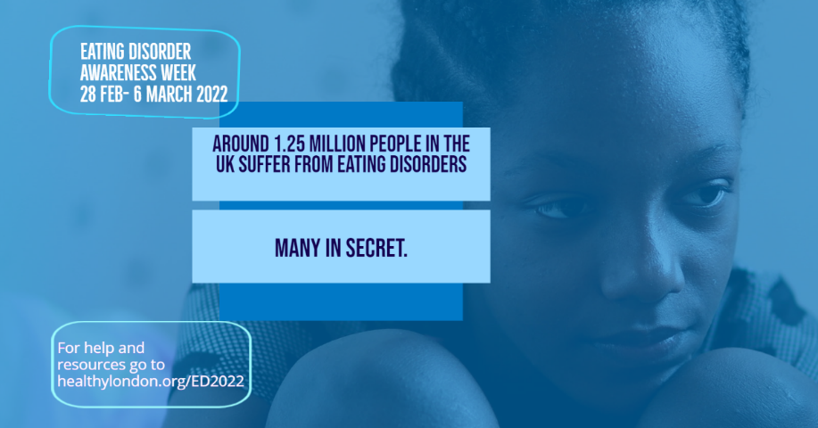
Instagram | You might not know who could be silently struggling with an #eating disorder.  Find resources including podcasts, blogs and advice to help a loved one with an eating disorder at  Healthy London Partnership or  Beat  @HealthyLDN @beatED | 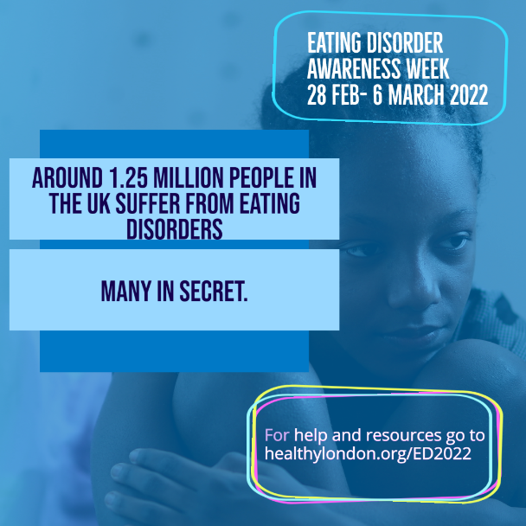

Eating Disorders –Men
Twitter | Did you know that up to a quarter of #eatingdisorder sufferers are men? But many men are still undiagnosed. It can happen to anyone  Find resources including podcasts, blogs and how to get help at  Healthy London Partnership or  Beat  @HealthyLDN @beatED | 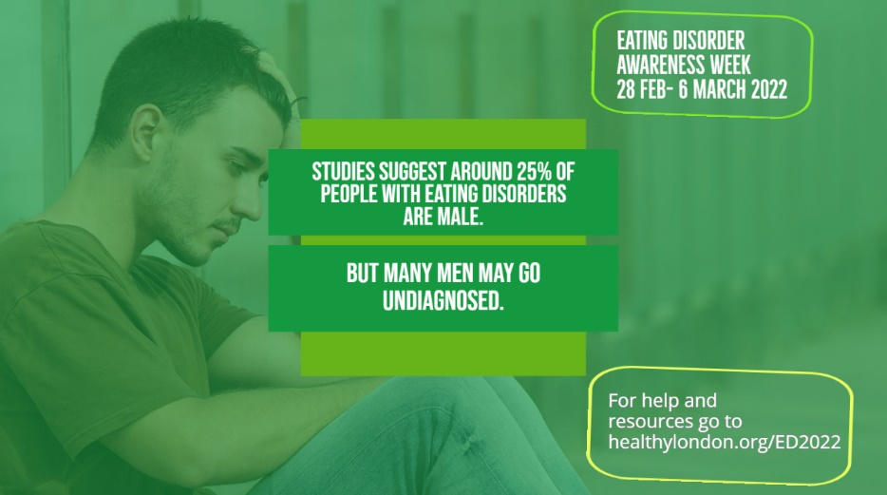
Facebook/LinkedIn | Did you know that up to a quarter of #eatingdisorder sufferers are men? But many men are still undiagnosed. It can happen to anyone  Find resources including podcasts, blogs and how to get help at  Healthy London Partnership or  Beat | 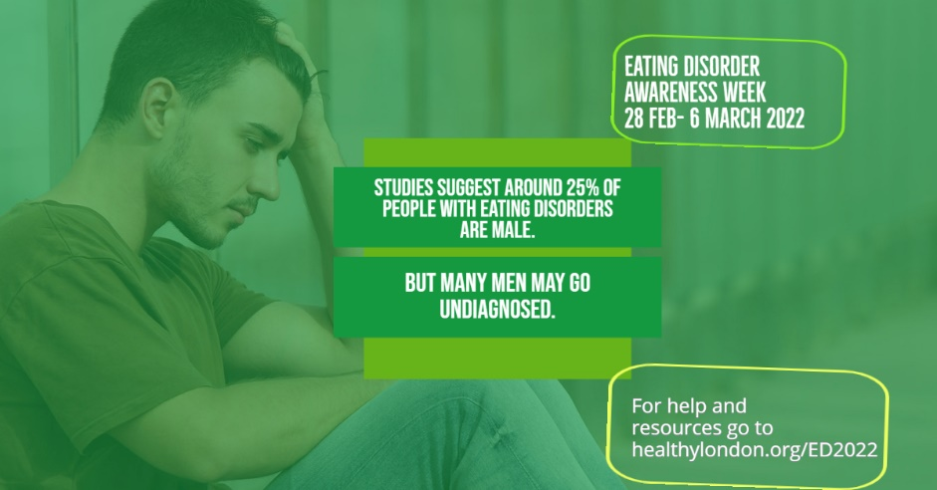
Instagram | Did you know that up to a quarter of #eatingdisorder sufferers are men? But many men are still undiagnosed. It can happen to anyone  Find resources including podcasts, blogs and how to get help at  Healthy London Partnership or  Beat  @HealthyLDN @beatED | 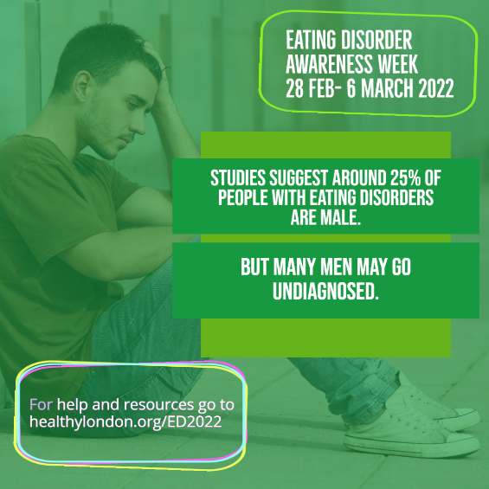

Help and support
Twitter | If you’re struggling with an #eatingdisorder, reach out. Help is available for a road to recovery  Find resources including podcasts, blogs and how to get help at  Healthy London Partnership or  Beat  @HealthyLDN @beatED | 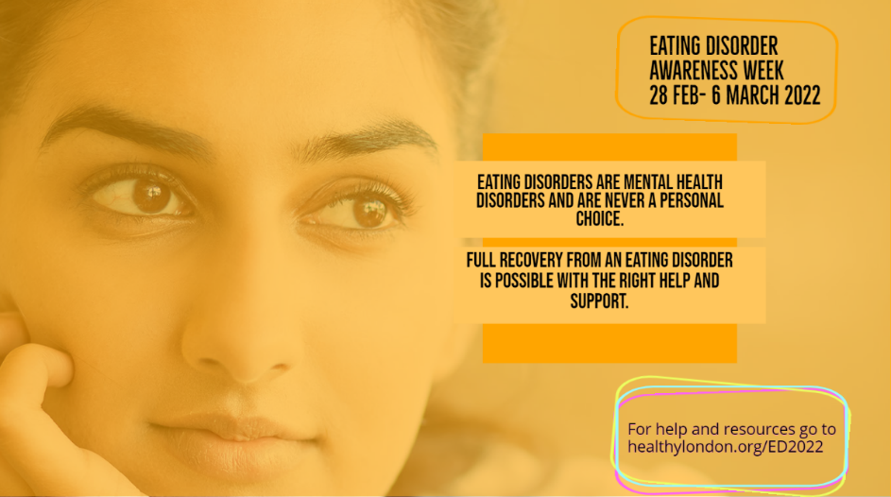
Facebook/LinkedIn | If you’re struggling with an #eatingdisorder, reach out. Help is available for a road to recovery  Find resources including podcasts, blogs and how to get help at  Healthy London Partnership or  Beat | 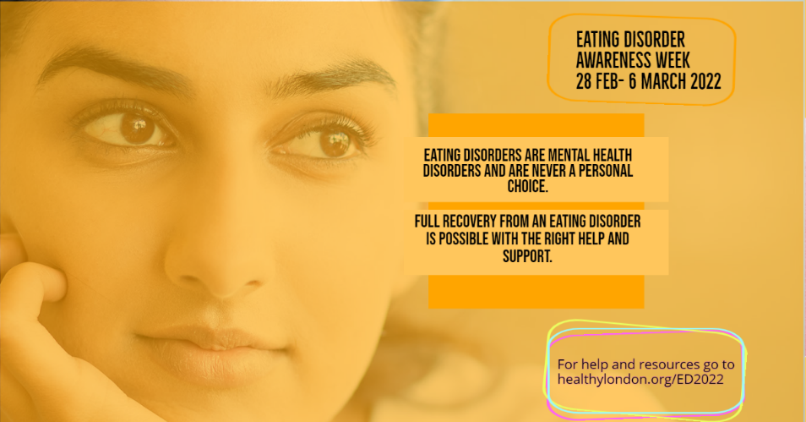
Instagram | If you’re struggling with an #eatingdisorder, reach out. Help is available for a road to recovery  Find resources including podcasts, blogs and how to get help at  Healthy London Partnership or  Beat  @HealthyLDN @beatED | 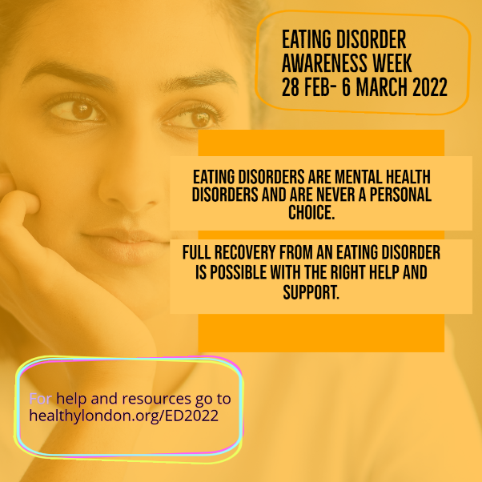

Resources

General information on eating disorders:
- Beat Eating Disorders
- NHS information on eating disorders
- HLP Eating Disorders Awareness Week 2022 webpage

Resources on eating disorders for children and young people and their families:
- Good Thinking advice page advice for young people on managing eating disorders
- Good Thinking advice for parents and carers supporting children and young people with eating disorders
- In this video, Hope Virgo discusses eating disorders and reaching out for support, produced in partnership with Thrive LDN and MIND West London
- In this video, Dave, a stand-up comic and Beat volunteer shares his experiences around diagnosis, support and recovery journey

Resources for healthcare professionals:
- Free online mental health training module on eating disorders for acute paediatric professionals, developed by Healthy London Partnership, in collaboration with Health Education England, the Paediatric Clinical Care in Practice (PCCP)
- Eating disorder training for medical students and foundation doctors: HEE elfh Hub (e-lfh.org.uk)
- HLP’s shared learning webinar on the differences between disordered eating and eating disorders

For other professionals supporting children and young people:
- Guidelines for VCSE professionals on referring CYP with eating disorders
- Guidelines for primary care professionals
- Guidelines for education professionals
- Beat training and events

