TOUCHSTONE
JOB DESCRIPTION
PEER SUPPORT WORKER – LEEDS MENTAL WELLBEING SERVICE

Grade: NJC Scale Points 7 – 11, starting at £19,554 pa/pro rata
Hours: 1 x 25 hours per week
1 x 16 hours per week
Responsible to: LMWS Peer Support Coordinator
Employing Body: Touchstone – Board of Trustees
Location: Leeds

BACKGROUND
Touchstone is part of the new Primary Care Mental Health Service (PCMHS) for Leeds the Leeds Mental Wellbeing Service (LMSW). This exciting new partnership will mobilise and deliver an integrated service to offer primary care based mental health support for people with mild to moderate common mental health problems. Together, our partnership will help thousands of people in Leeds to increase their resilience and live their best lives within their community. The service comprises:

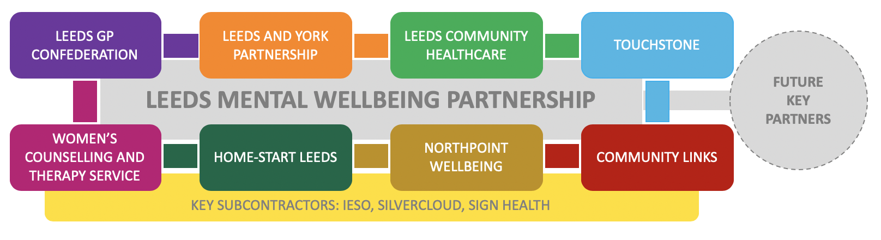

PURPOSE OF THE ROLE
The Peer Support Workers will provide emotional and practical support to service users of the Leeds Primary Care Mental Health Partnership teams.
The post holder will:
- Develop skills in working with service users with a variety of social and health support needs.
- Build a relationship of trust with service users and understand the importance of empowering them.
- Assist service users to enable them to achieve their personalised support outcomes.
- Work as part of a multi-disciplinary team to deliver a high standard of support to our service users.
- Be prepared to share own experiences and role model recovery.
- Identify barriers and gaps in services, state how they could be improved and identify good practice.
- Identify and attend appropriate training and development opportunities as required.
- Work in partnership with the Peer and Volunteer Development worker and Peer Support Coordinator to access personal support each week in order to improve own self-confidence to do the job, and manage personal wellbeing.

KEY RESPONSIBILITIES
- To develop and maintain positive and professional relationships with service users.

- To provide emotional and practical support and advice to enable service users to improve their quality of life, develop their skills and make decisions about their future.

- To encourage and motivate clients to engage with appropriate services.

- To work alongside all staff in the LMWS to assess service user’s needs, and implement individual Signs of Safety plans.

- To accompany service users to other projects and external appointments.

- To encourage and support service users to participate in meaningful activities.

- To respond appropriately to all service user needs to safeguard the wellbeing of all service users and staff.

- To maintain accurate records of work undertaken with service users around their support, and any other records as required by the Peer Support Coordinator.

- To attend and participate in team meetings and other team events.

- To liaise with external agencies as required.

- To work to actively combat mental health inequalities, applying your knowledge of the social determinants of mental health in Leeds, and how some communities are at greater risk of poorer mental health
GENERAL
- To attend a full induction programme consisting of: development and wellbeing planning, goal setting, shadowing, and an introductory peer support training course.

- To be responsible for personal learning and development and undertake appropriate training, both mandatory and optional to increase knowledge, skills and awareness.

- To visit relevant external agencies who work with LMWS.

- To attend regular support sessions, reflective practice, supervision and performance reviews with the Peer Support Coordinator, in line with the organisations performance management policies and procedures.

- To work at all times as part of a team. This includes working with other staff, attending team and staff meetings and developing a teamwork approach to all aspects of the organisation’s work.

- To be flexible in the approach to hours of work including evening and weekend work as required by the service.

- To be aware of and employ the general practices of the LMWS Partnership /Touchstone regarding safeguarding, and health and safety policies and ensure these are adhered to at all times.

- To operate within the aims, policies and practices of LMWS Partnership /Touchstone at all times and to be committed to and promote the organisations equal opportunities and anti-discriminatory policies and to promote this with staff.

- To ensure information is dealt with in accordance with LMWS Partnership /Touchstone policies around confidentiality, communications, internet, e-mail and telecommunications, and steps are taken to ensure that confidential information is secure e.g. service user data.

- To keep the Peer Support Coordinator Worker informed about any serious and untoward incidents, safeguarding, health and safety, and/or financial issues.

- To undertake any other duties as directed by the Peer Support Coordinator in line with the responsibilities of the post.

