Returning to Isleworth
A Guide to the day

- Don’t forget your new essential kit before you leave the house – mask, keys, phone and laptop! Plus, anything else you might need | 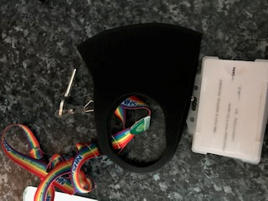
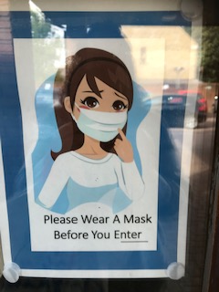 | - Put your mask before entering the building.
- When entering either ensure you have a key to open the door or ring someone in your bubble to come and let you in (do not ring the buzzer and disturb the GP staff): | 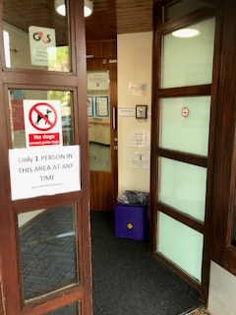
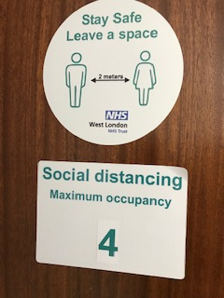 | - Each office shows how many can be in the room at any one time. If you are unsure if the room is at capacity, please knock and scan the room from the doorway
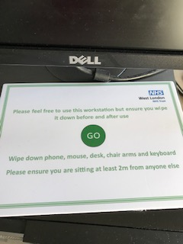  ONLY sit at Desks marked for use | DO NOT sit here  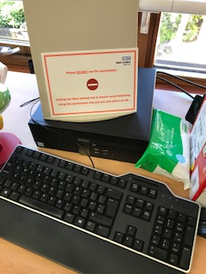
- When you arrive please wash / sanitize your hands and wipe down your workstation | 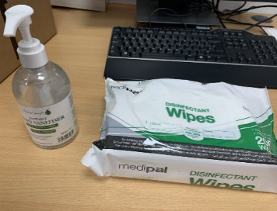
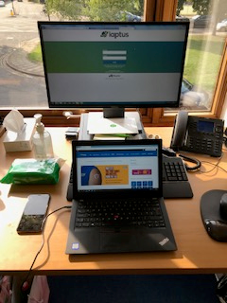 | - Each work station has hand sanitizer and wipes, set up your lap top and mobile for the day

The first person to arrive each morning should:
- Unlock the doors and open the windows in every room
- Switch the old duty mobile on and leave beside the thermometer on the filing cabinets in the CBT Office

- Remember to keep a social distance as much as possible and wear your mask when using a shared office | 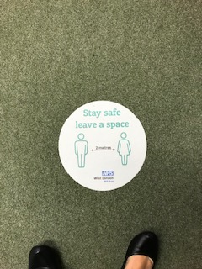
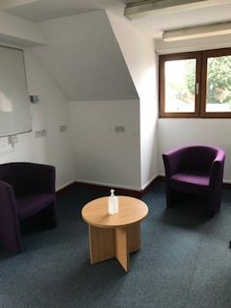 | - Prepare your clinical room- put everything you need in there (pens, paper, forms etc)
- DO NOT move the chairs from their current position / from behind the yellow tape. The seating arrangements have been 2 meter distanced | 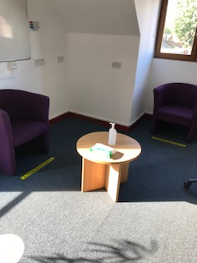

Returning to F2F Appointments
At The Isleworth Centre

- Admin will have completed the screening questions prior to booking the appointment. Screening Questions can be located on IAPTus Documents under the Covid-19 Category | 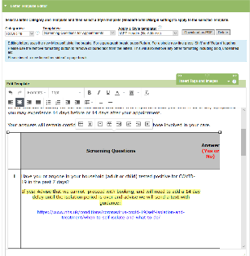
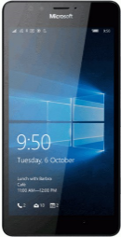 | - When your client arrives for their assessment appointment / first treatment appointment, they will call the ‘Old’ duty mobile.  This is kept in the key box in the CBT Office, however the first person in each day, should switch this on and place next to the thermometer on the filing Cabinets, closest to the door in the CBT Office.  When your client calls, it is your responsibility to answer. You will need to run through the screening questions again and save this document on IAPTus
- Pop your mask on, use the disinfectant wipes to wipe down the thermometer and the mobile. Grab the temperature gun and meet them at the door | 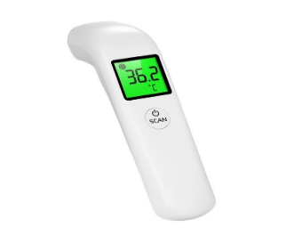
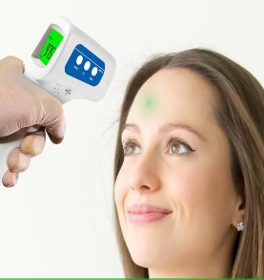 | - You will need to be within arms-reach of the client to get an accurate reading. All you need to do is point and press ‘scan’  Please ensure the mobile and thermometer are returned to the CBT office before entering your session
- Please take your client directly to the room you will be seeing them in. Check the corridor is clear. If not, please maintain 2meter distance by waiting until they have entered their room or left corridor | 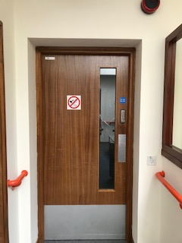
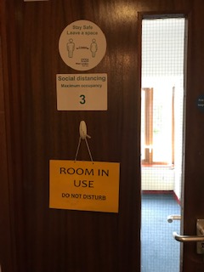 | - Please show the client directly into the room that you will be seeing them in.
- Conduct your session. If it is a treatment appointment, please ensure client is aware to call your work mobile when they arrive for future sessions. | 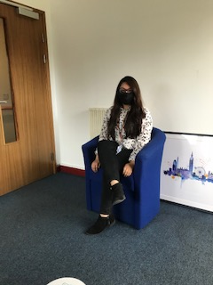
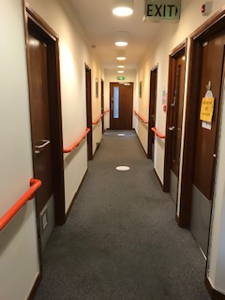 | - Ensure corridor is clear when you exit, if not, please maintain 2meter distance by waiting until they have entered their room or left corridor
- Please return to the room, wipe down the area with the disinfectant wipes, including the corridor and room door handles and lift buttons (if used).

Prop the door open to ventilate the room
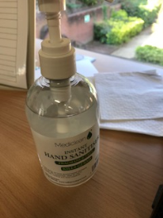 | - Please then either wash or sanitize your hands
At the end of the day:  - Wipe down the workstation and arms of the chair  - Clear all clutter from desks, including pens, paper and envelopes  - Place the ‘Go’ card back on the keyboard  - Ensure the disinfectant wipes and sanitizer are left on the desk. | 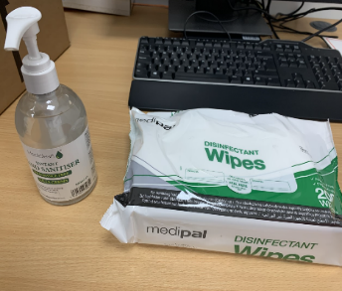

Please keep the office clean, tidy and clear of clutter
The last person in each room must:
- Close all windows
- Lock the room / office

