Children and Young People Mental Health and Crisis messaging toolkit: to cascade key messages during wave 2 of Covid19.

During the summer senior mental health leads in London agreed that children and young people’s mental health (CYPMH) should be a priority focus of the mental health COVID-19 recovery. As a result, the Healthy London Partnership CYPMH Programme have established a CYPMH COVID-19 Recovery Steering Group, chaired by our two Senior Responsible Officers representing the Cavendish Square Group, Paul Jenkins, Chief Executive Officer at The Tavistock and Portman NHS Foundation Trust, and Charlotte Harrison, Medical Director at South West London and St George’s Mental Health NHS Trust. The Steering Group has prioritised the development of consistent communication messages about CYPMH. to link into existing communication channels and community targeted messaging to ensure there is joined up messaging across the system in London.

During wave 1 of Covid19 referrals to CYP Mental Health Services dropped to 47% of the expected rate.

There has been a rise in CYP MH presentations to A&E across London despite the availability of all age 24/7 crisis lines that have been established to provide appropriate urgent support.

There is outdated crisis information online including (signposting to NHS111 over the NHS urgent mental health crisis helplines that should be used.) It is also not always clear that these helplines are available for children and young people, parents and their families.

Whilst specific arrangements and support offers vary across boroughs, this document sets out key messages with supporting assets that will:
- Address barriers to accessing services by building on the ‘your NHS is here for you’ messaging. This will provide assurance to CYP and their families that CAMHS services are open and safe from Covid.
- Promote all age 24/7 crisis lines and provide clear and consistent messaging on how to seek help in a crisis.

What is included in the toolkit: To cascade key messages during wave 2 of Covid19.
- Children and Young People Mental Health and Crisis messaging toolkit
- A selection of social media images for specific posts
- How to change supporting images according to the organisation/ industry: Logo, CYP crisis number, Hashtag
- Downloadable PowerPoint document for all images and content: images targeted CYP and images targeted for the parents/carers looking after the young people.

KEY MESSAGES TO SHARE ON DIGITAL CHANNELS

CYP MH services and Crisis Messaging toolkit

Social media channel | Message | Imagery matched with social channel
CYPMH Services ‘here for you’ messaging |  | CYP | Parents/carers
Twitter | Are you a young person struggling with mental health? Please know that our #CYPMH services are here for you.  Call our 24 hr #MentalHealth crisis line if you need urgent support or advice XXXXX  #NHSHereForYou  *Suggested hashtags to add*  #NHSHereForYou  #CYPMH  #MentalHealth  Please add our Twitter handle @HealthyLDN  *Tag your organisation if on twitter * | 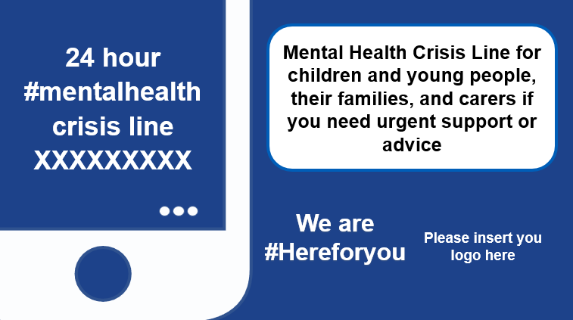  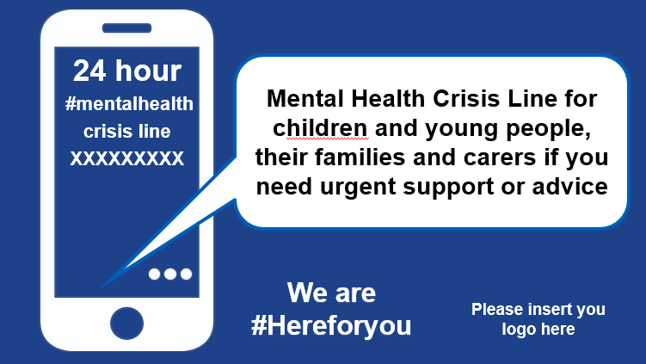
Facebook/ LinkedIn/ Instagram | If you are a young person struggling with your mental health or are worried about a young person you are caring for  please know that our #CYPMH services are here for you.  If you need urgent support or advice you can call our 24 hour #MentalHealth crisis line XXXXX  #NHShereforyou  *Suggested hashtags to add*  #NHSHereForYou  #CYPMH  #MentalHealth  Please add our Twitter handle @HealthyLDN  *Tag your organisation if on twitter * | 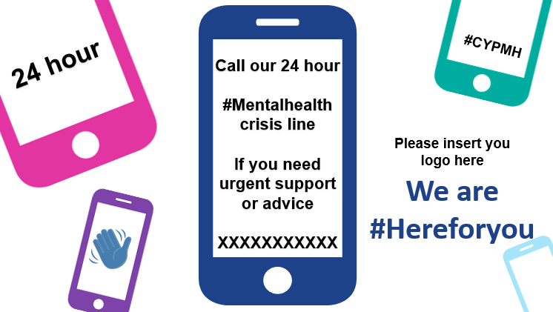  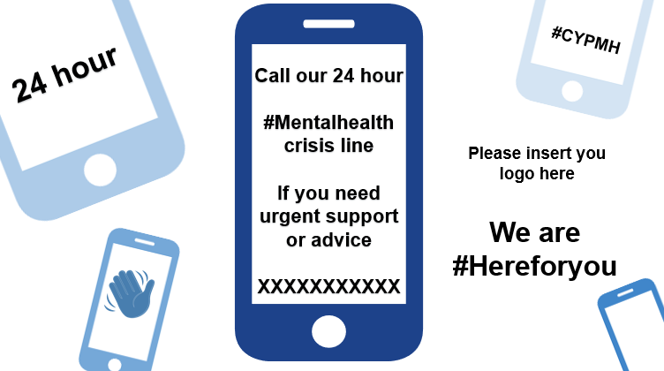

Parent/carer / CYPMH Services ‘here for you’ messaging

Twitter | Are you a parent or carer of a young person struggling with their #MentalHealth, please know that our #CYPMH services are here for you.  Call our 24 hour mental health crisis line XXXXX  #NHShereforyou  *Suggested hashtags to add*  #NHSHereForYou  #CYPMH  #MentalHealth  Please add our Twitter handle @HealthyLDN  *Tag your organisation if on twitter * | 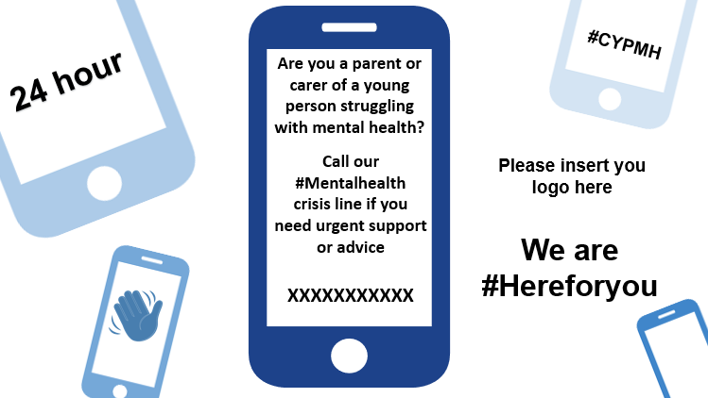
Facebook/ LinkedIn/ Instagram | If you are a parent or carer of a young person struggling with their mental health, please know that our #CYPMH services are here for you.  If you need urgent support or advice you can call our 24 hour mental health crisis line XXXXX  #NHSHereForYou  *Suggested hashtags to add*  #NHSHereForYou  #CYPMH  #MentalHealth  Please add our social media handle @HealthyLDN  *Tag your organisation if on twitter *

CYP ‘services are safe’ messaging
Twitter | If you are asked to attend our #CYPMH service, you might see the following changes:  Please contact for further details XXXXXXXX  *Suggested hashtags to add*  #NHSHereForYou  #CYPMH  #MentalHealth  *Tag your organisation if on twitter *  (👉 link to specific CYP page with more information) | 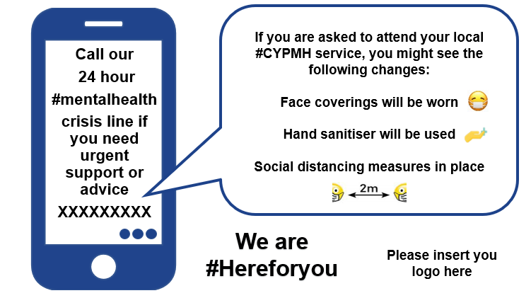
Facebook/ LinkedIn/ Instagram | If you are asked to attend our #CYPMH service, you might see the following changes:  Face coverings will be worn  Hand sanitiser will be used  Social distancing measures in place  Please contact for further details XXXXXXXX  *Suggested hashtags to add*  #NHSHereForYou  #CYPMH  #MentalHealth  *Tag your organisation if on twitter *  (👉 link to specific CYP page with more information)

CYP/ Crisis line ‘here for you’ messaging |  | CYP | Adults
Twitter | If you are a young person and living in xxxxx (insert location) #MentalHealth crisis lines are #HereForYou if you need urgent support or advice.  24hours, 7 days all year round.  *Suggested hashtags to add*  #NHSHereForYou  #CYPMH  #MentalHealth  Please add our Twitter handle @HealthyLDN  *Tag your organisation if on twitter * | 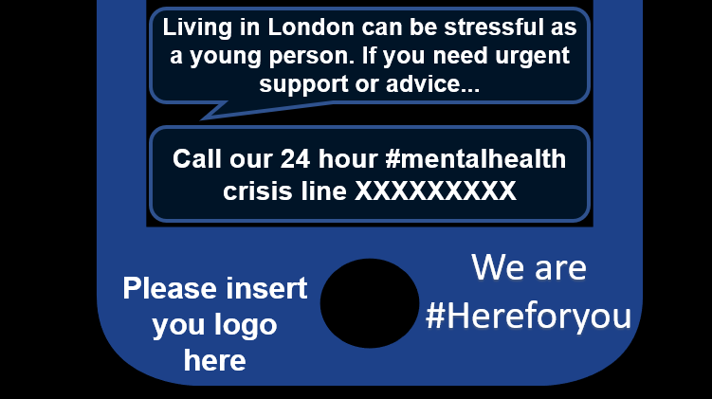  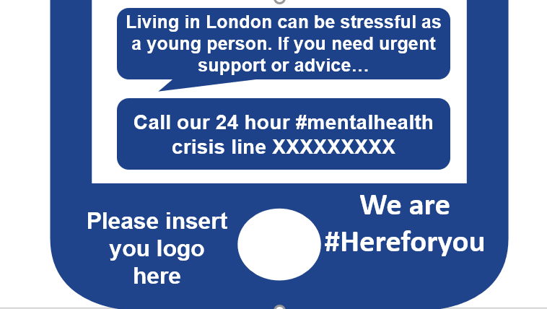

Facebook/ LinkedIn/ Instagram | If you are a young person or care for a young person and need URGENT support or advice call the 24/7 #mentalhealth crisis line is #HereForYou  XXXXX  You can call this number to get help or advice in a crisis from trained mental health advisors and clinicians, 24 hours a day, 365 days a year.  Website link xxxxxxx  *Suggested hashtags to add*  #NHSHereForYou  #CYPMH  #MentalHealth  Please add Healthy London Partnership social media handle @HealthyLDN  *Tag your organisation if on certain social media platforms * | 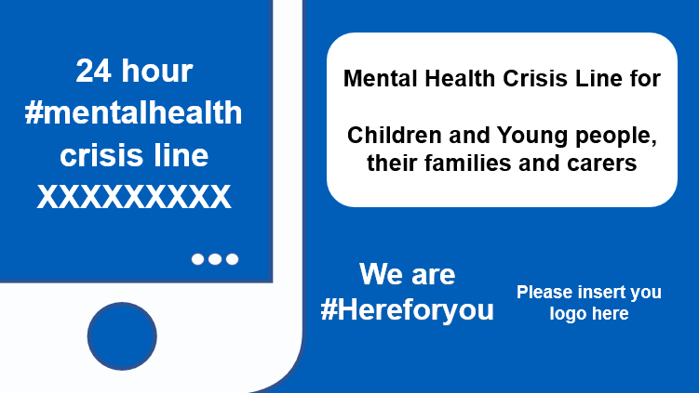

How to change images

- Please download the PowerPoint document which has all images required for the messaging.
- Please select an image. For each image you can insert specific logo image where is states “insert logo here”. Additionally, on each image will also stated “XXXX” please add the updated CYP Mental Health crisis number
- Once image has been adjusted accordingly. You can use the snipping tool and cut the image and save as. Or change all images according to your organisation, save as PDF. Finally attach to your chosen social media platform.

