- Good Thinking digital wellbeing service
Twitter | Times may feel uncertain as London deals with the implications of BREXIT, and it's perfectly normal to feel worried.  @GoodThinkingUK has a range of FREE apps and resources to help with anxiety, low mood, sleeping difficulties or stress.  ➡️ www.good-thinking.uk | 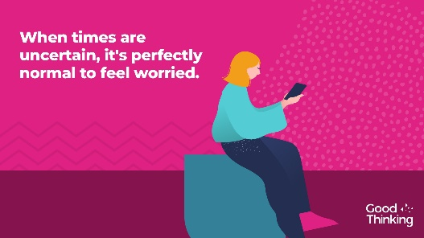  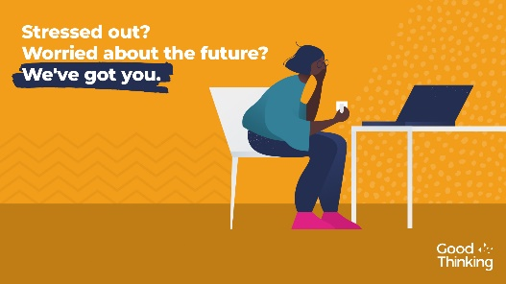
Instagram | When times are uncertain, it is perfectly normal to feel worried. Help is available. There are a range of free apps and resources from @goodthinkinguk to help if you have anxiety, low mood, sleeping difficulties or stress.  ➡️ www.good-thinking.uk  #MentalHealth #Wellbeing #London #Londoners #Support | 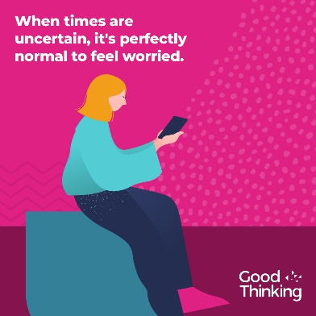
LinkedIn and Facebook | Times are uncertain as Londoners deal with will Covid-19 measures, the impact of BREXIT and other challenges, it's perfectly normal to feel worried. @GoodThinkingUK help and support is available if you have anxiety, low mood, sleep difficulties or stress.  There's lots you can do to build resilience, stay positive and boost mood. With more than 120 online resources, including wellbeing information sources; guides to improving mental health; courses on and offline; mobile apps and other therapy approaches, Good Thinking also provides articles, podcasts, worksheets and a self-assessment tool.  Visit: www.good-thinking.uk
- Wellbeing guidance in 27 languages
Twitter | It's normal to feel stressed or worried in these difficult times.  That’s why @ThriveLDN, @DOTW_UK & @MayorofLondon have teamed up to create six practical steps to help you cope and stay well.  Available to download in English and 26 other languages: https://www.doctorsoftheworld.org.uk/wellbeing-guidance | 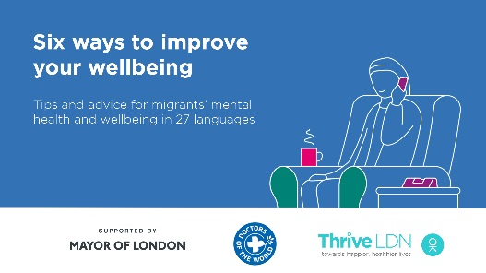  Video link: https://thriveldn.co.uk/wp-content/uploads/2020/09/Wellbeing-Guidance-FINAL.mp4  (open link, then right click and ‘save as’ to download)
Instagram | It's normal to feel stressed or worried in these difficult times.  @ThriveLDN, @dotw_uk & @mayorofldn have teamed up to create six practical steps to help you cope and keep well.  Available to download for free in English and 26 other languages: https://www.doctorsoftheworld.org.uk/wellbeing-guidance  Remember, it is OK not to feel OK.  #MentalHealth #ThriveLDN | 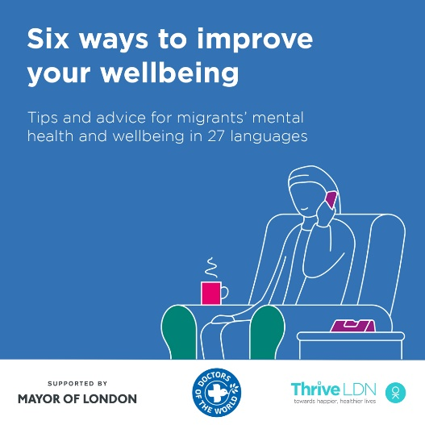  Video link: https://thriveldn.co.uk/wp-content/uploads/2020/09/Wellbeing-Guidance-FINAL.mp4  (open link, then right click and ‘save as’ to download)
Facebook | It's normal to feel stressed or worried in these difficult times.  Thrive LDN, Doctors of the World UK and the Mayor of London have teamed up to create six practical steps to help you cope and keep well.  Available to download for free in English and 26 other languages: https://www.doctorsoftheworld.org.uk/wellbeing-guidance  Remember, it is OK not to feel OK.  #MentalHealth #ThriveLDN #Support #Wellbeing | Video link: https://thriveldn.co.uk/wp-content/uploads/2020/09/Wellbeing-Guidance-FINAL.mp4  (open link, then right click and ‘save as’ to download)  Partner accounts to tag:  Thrive LDN, MoL, DoW

