COVID -19 Conversations on vaccinations recording tool

The following document has been created to support clinicians reach an understanding of whether an adult with known learning disability has capacity to make a decision to have the COVID- 19 vaccination in relation specifically to the COVID- 19 Pandemic.
It is to be used in partnership with the COVID-19 Conversations Accessible/Easy Read tool.

The pages of the recording tool have an exact copy of each page of the Conversations easy read document with a column of advice about ancillary questions and checks that could be helpful to open up dialogue and/or assess the person’s comprehension. The tool is designed for use predominantly with Adults with Learning Disability and so it is important to evidence how the person has met the first test of the Mental Capacity Act (2005) that there is an impairment of mind or brain (on the demographics page).

There are then three columns for the clinician to record the secondary test laid down by the Mental Capacity Act 2005.
- Can the person understand the information?
- Can the person retain information long enough to make the decision?
- Can the person weigh it in the balance?
- Can the person communicate a decision?

The final column and last pages of the document give the clinician space to consider what they have heard and seen and assimilate these aspects of evidence into a view regarding the person’s capacity to make informed decisions regarding their future treatment should they be unfortunate enough to contract Covid-19.

COVID-19 Conversations on Vaccination recording tool.

Person’s first name in full | Person’s surname in full | Known as (if different) | Date of Birth | NHS Number

Usual Address | Current Address | GP Details
Phone No: | Phone No: | Phone No:  Email:

Care/Living Environment Arrangements (Circle or highlight which applies)
Person lives in own home without support | Person lives in own home with support from: (name agency or relationship) | Person lives in Shared Lives (Adult fostering) placement | Person lives in Supported living environment managed by (Name organisation) | Person lives in Registered residential home managed by (name organisation) | Person lives with family members (specify relationship & who owns the property) | Other (please specify)
Mental Capacity Act legal status: Does anyone claim to be acting as or have:
Court Appointed Deputy for Property and Financial Affairs |  | Court Appointed Deputy for Personal Welfare |  | Lasting Power of Attorney for Property & Financial Affairs |  | Lasting Power of Attorney for Health and Welfare |  | Enduring Power of Attorney | None identified
What evidence has been presented to demonstrate that this is true? |  |  |  |  | Have you verified this is legitimate with the Office of the Public Guardian?
Conversation Date/s |  |  | Completed by: |  |  |  | Designation:
Contact Details

Evidence of Impairment of Mind or Brain.

Whilst this recording tool is not a formal capacity assessment, it’s purpose is to support and inform those leading decision-making about a person at a time of need. It is important that accurate information is provided to enable timely legally appropriate decision-making;

The first principle of the Mental Capacity Act (2005) is to assume capacity unless there is cause to doubt; the following questions are important in clarifying for the decision-maker that there is impairment of mind or brain.

Is the person on their GP’s register of Adults with Learning Disability? | Yes | No | Unknown
Did the person attend a school for people with severe learning disability? (Name of school) | Yes | No | Unknown
Does the person have a genetic condition that is strongly associated with learning disability (e.g. Down Syndrome or Fragile X)? | Yes | No | Unknown

Has the person been assessed as eligible to receive learning disability community services?
In Local Adult Services there are three agencies offering specialist services to adults with learning disability: Circle which apply;

Community Therapy and Nursing Team for  Adults with Learning Disability (GSTT) | Specialist Psychiatry, Psychology and  Behavioural Support Service (SLAM) | Local Authority Learning Disability  (or equivalent) Team

Outline below the Nature of the work undertaken by the Agencies involved and over what time period (Single or interagency agreement on diagnosis, date that working hypothesis of learning disability (Eligibility) was made, by whom; and details of information provided that informed decision. Subsequent Team activity with or on behalf of the person.

Guide for Service User |  | Staff Guide | Did person demonstrate ability to understand this information? How did they achieve that? | Did person demonstrate they were able to weigh information in the balance? How? | Did the person express any opinion or preference at this point in the conversation? | HCP analysis/comment
 | COVID-19 (also called Coronavirus) is a new illness.  It affects people in different ways  It can make you very poorly.  It has killed some people. | Start a conversation – what do you know about COVID-19?  Are you worried about getting it?
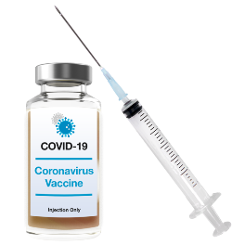 | The COVID-19 vaccine is an injection. | Tell the person what a vaccine is.  Similar to when they have a flu jab.
 | The vaccine may help to stop you getting COVID-19. | Tell the person about the benefits of having the vaccine.
Guide for Service User |  | Staff Guide | Did person demonstrate ability to understand this information? How did they achieve that? | Did person demonstrate they were able to weigh information in the balance? How? | Did the person express any opinion or preference at this point in the conversation? | HCP analysis/comment
 | It also helps to stop you giving COVID- 19 to other people. | Tell the person about how it can stop them giving the virus to someone else such as a loved one.
X 2 | You will have two injections. | Tell the person about need for two doses.
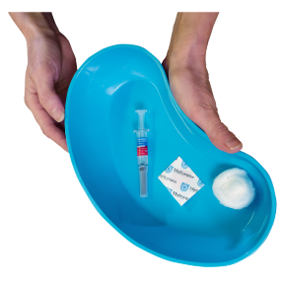 | You will have the 1st injection today.  You should not attend a vaccine appointment if you are unwell, self-isolating, waiting for a COVID-19 test or unsure if you are fit and well. | Discuss if they would be having the injection today Explain what to do if unwell at next appointment.
Guide for Service User |  | Staff Guide | Did person demonstrate ability to understand this information? How did they achieve that? | Did person demonstrate they were able to weigh information in the balance? How? | Did the person express any opinion or preference at this point in the conversation? | HCP analysis/comment
3-12 weeks | You have the 2nd injection between 3 and 12 weeks. | Tell the person when they get the second dose.
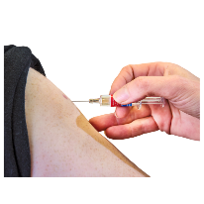 | You have the injection in your arm. | Tell the person it’s an injection,
 | You may feel a little scratch | Tell the person what it feels like.
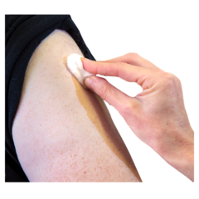 | The nurse will put a plaster on your arm. | Tell the person what you are going to do next.
Guide for Service User |  | Staff Guide | Did person demonstrate ability to understand this information? How did they achieve that? | Did person demonstrate they were able to weigh information in the balance? How? | Did the person express any opinion or preference at this point in the conversation? | HCP analysis/comment
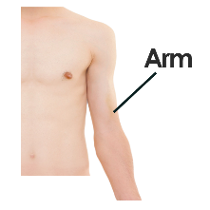 | Your arm might be a little red and sore afterwards. | Explain about a painful, heavy feeling and tenderness in the arm where you had your injection.
 | You may feel tired, | Explain about tiredness.
 | You may have a headache. | Explain about headaches.
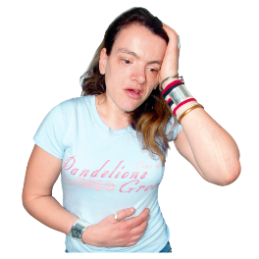 | You might feel a little poorly a few days later. | Explain about general aches.
Guide for Service User |  | Staff Guide | Did person demonstrate ability to understand this information? How did they achieve that? | Did person demonstrate they were able to weigh information in the balance? How? | Did the person express any opinion or preference at this point in the conversation? | HCP analysis/comment
 | You might have flu like symptoms. | Explain about mild flu like symptoms.
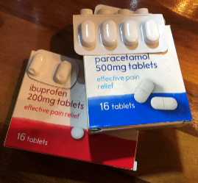 | You can take some pain killers to help with this. | Tell the person what type of pain relief they can take.
 | Some people might have a temperature. | Explain about what to do if side effects are bad and if temperature (might indicate COVID-19).
 | If you feel unwell you should tell someone.  Ask someone to call your doctor or if you or they are worried to call 111. | Explain what to do if unwell.
Guide for Service User |  | Staff Guide | Did person demonstrate ability to understand this information? How did they achieve that? | Did person demonstrate they were able to weigh information in the balance? How? | Did the person express any opinion or preference at this point in the conversation? | HCP analysis/comment
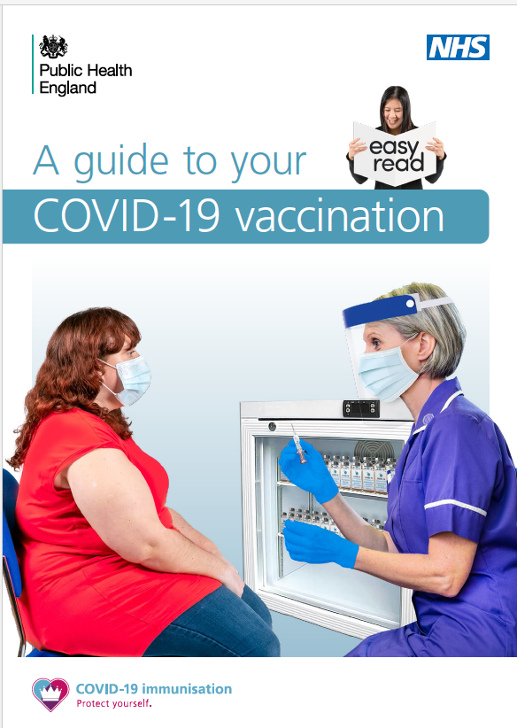 | You will be given a leaflet. | Explain about leaflet and what to do if they have any side effects.
 | You need to come back in 3 -12 weeks’ time for the 2nd injection. | Explain about the need for 2nd dose.
1week | After a week you should be safer from COVID-19. | Explain that the vaccination process is complete & have some protection from COVID-19.
 | Is there anything you want to ask me? | Ask the person if they have any questions.
Clinical Analysis of Assessment

This page is for the assessing clinicians to formulate a working hypothesis on the person’s comprehension of the content of the whole package of information provided (The MCA does not require an individual to remember every detail, but to have demonstrated they understand the global main points, risks and benefits). It might be useful to think about this in terms of themes, for example: That COVID-19 is an infectious disease that has capacity to kill people, some people are more at risk than others, there are options for treatment but people receiving treatment are still dying from the disease. Continue on additional pages if necessary.
Use the space below to indicate how and to what extent the person has comprehended the information presented. Consider verbal and non-verbal intentional communication as well as body language and facial expression. Were there any particular strengths in the person’s comprehension of areas of the discussion? Were there any particularly significant gaps in the person’s comprehension? | Use this box to indicate the extent to which the person was able to retain the information presented long enough to discuss the topic as a whole after you had gone through the tool together. Did their comprehension grow as you worked through the tool together or did they retain only the first few key points or one significant key point. Did the person achieve a broad retention of the majority of the key points presented? How have you come to this conclusion?
Use the space below to indicate how and to what extent the person has been able to weigh the information conveyed in the balance. Again, it is important to cite all forms of communication, verbal, non-verbal, facial expression and body-language where relevant. Especially important is to consider whether the person asked supplementary questions to support their growing comprehension. | Use this box to indicate what the person decided. Whether their communication regarding their wishes was consistent and remains so, or appeared confused dependent upon the subtopic in question. How can you be assured that this is the person’s views.
Please use this space to log any further information such as whether the person was supported by a relative or third party, and if that was the case whether that person exerted any influence on the process or person’s communication and expression of wishes.

Clinicians may wish to revisit the assessment at a further appointment and review what the person said with them after a few days or a week to check that they are consistent in their responses. This will depend on how the person responded to the initial assessment and information presented, and requires clinicians to use their own judgment about the information they have gathered. It may also be necessary to revisit the process if more vaccination options become available as developments are made.

Clinician signature and full name. |  | Clinician signature and full name
Date | Date of follow up if applicable. | Date | Date of follow up if applicable.

Action Plan

Ensure the person has the most up to date PHE England/Mencap Easy-read guidance on COVID- 19 vaccine.
Ensure the person knows how/where to get help if they become unwell.
Upload a copy of this document and any other relevant documents to the patient record.

