Pan London COVID-19 Suspected Breast Cancer/Breast Clinic Referral Form

REFERRAL DATE: «REFERRAL_Event_Date»

E-referral is the preferred booking method for suspected breast cancer/breast symptoms referrals.
All referrals should be made within 24 hours.
Fax is no longer supported due to patient safety and confidentiality risks.

PATIENT DETAILS

SURNAME: «PATIENT_Surname» FIRST NAME: «PATIENT_Forename1» TITLE: «PATIENT_Title»
GENDER: «PATIENT_Sex» DOB: «PATIENT_Date_of_Birth» AGE: «PATIENT_Age» NHS NO: «PATIENT_Current_NHS_Number»
ETHNICITY: LANGUAGE:

INTERPRETER REQUIRED TRANSPORT REQUIRED

PATIENT ADDRESS: «PATIENT_House» «PATIENT_Road», «PATIENT_Town» POSTCODE: «PATIENT_Postcode»

DAYTIME CONTACT: «PATIENT_Main_Comm_No»

HOME: «PATIENT_Main_Comm_No» MOBILE: «PATIENT_Mobile_No» WORK: «PATIENT_Alt_Comm_No»
EMAIL:

CARER/KEY WORKER DETAILS

NAME: CONTACT: RELATIONSHIP TO PATIENT:

COGNITIVE, SENSORY OR MOBILITY IMPAIRMENT

COGNITIVE SENSORY MOBILITY DISABLED ACCESS REQUIRED

PLEASE INCLUDE RELEVANT DETAILS:

SAFEGUARDING
SAFEGUARDING CONCERNS
PLEASE INCLUDE RELEVANT DETAILS:

GP DETAILS
USUAL GP NAME: «PATIENT_Usual_GP»
PRACTICE NAME: «PRACTICE_Name» PRACTICE CODE:
PRACTICE ADDRESS: «PRACTICE_BlockAddress»

BYPASS:
MAIN: «PRACTICE_Main_Comm_No» FAX: «PRACTICE_Fax_No» EMAIL:
REFERRING CLINICIAN: «REFERRAL_Clinician»

COVID – 19 STATUS (please tick one of the boxes below before referring)
 | Not at risk |  | At risk |  | At very high risk

Please indicate by ticking one box
SUSPECTED BREAST CANCER will be assessed within 2 weeks

BREAST SYMPTOMS (CANCER NOT SUSPECTED) will be assessed within 2 weeks
This form should NOT be used for patients who need to be referred because of a family history of breast cancer or for reconstructive surgery. Please refer by eRS or letter as per local guidelines.
SUSPECTED BREAST CANCER  (NICE NG12 CRITERIA)  Please only use this section if you suspect breast cancer:  30 years and over | BREAST SYMPTOMS  Cancer NOT suspected:
unexplained/discrete breast lump  unexplained lump in axilla  Skin changes that suggest breast cancer Tether / contour change/ peau d’orange  Unilateral nipple symptoms  Discharge: blood / watery  inversion / retraction / ulceration  other changes or concern | aged <30 years with a lump  Persistent asymmetrical nodularity or thickening at review after menstruation  Infection or inflammation that fails to respond to antibiotics  Unilateral eczematous skin of areola or nipple: Please do not refer until tried topical treatment such as 0.1% mometasone for 2 weeks  Please do not refer bilateral multiduct discharge.
Referral is due to CLINICAL CONCERNS that do not meet above criteria (the GP MUST give full clinical details in the ‘additional clinical information’ box at time of referral)
Recommendations for management of BREAST PAIN:
Breast pain alone is not a sign of breast cancer and should be managed with the following advice:
1) Provide patient with information sheet: https://breastcancernow.org/information-support/have-i-got-breast-cancer/benign-breast-conditions/breast-pain
2) If required, analgesia (e.g. 4-6 weeks NSAID [oral /topical]) or paracetamol
Recommendations for investigations and management of GYNAECOMASTIA see ABS guidelines:
https://associationofbreastsurgery.org.uk/media/65097/abs-summary-statement-gynaecomastia-2019.pdf

EXAMINATION FINDINGS
Please mark the breast diagram below and/or provide a clinical description below it.

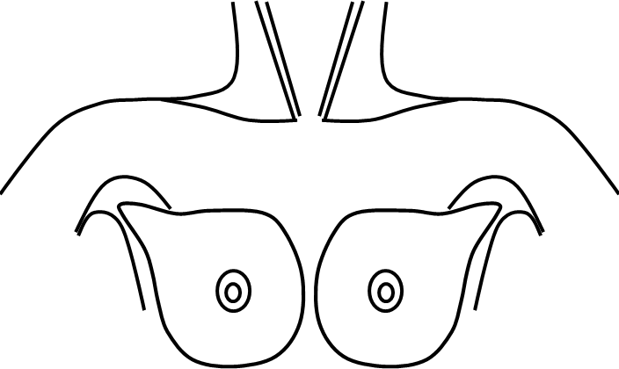

HOW TO MARK THE DIAGRAM
Place the mouse cursor over the diagram at the position of the lesion. Click the left mouse button. Use the keyboard to mark the diagram (X marks the lesion). Use the mouse or arrow keys to move left or right or to adjacent lines. Please do not press the <ENTER> key as it may cause alignment problems with your markers.

CLINICAL DESCRIPTION (including site, size, consistency and axillary involvement):

Additional clinical information:
Current Consultation:
«CURRENT_CONSULTATION»
Personal/relevant patient information:
Past history of cancer:
History of breast cancer:
Relevant family history of cancer:
I have discussed the possible diagnosis of cancer with the patient
The patient has been advised that they will be contacted by secondary care by telephone
I have counselled the patient regarding that they should prioritise this appointment but expect changes to routine investigations and management. I have offered the pan London
COVID -19 patient information leaflet. Offering written patient information increases patient experience and reduces non-attendance.
Press the <Ctrl> key while you click here to view the leaflet

This patient has been added to the practice suspected cancer safety-netting system
Press the <Ctrl> key while you click here to view Pan London Practice-based Suspected Cancer Safety Netting System

INVESTIGATIONS
Please ensure this referral includes ALL the relevant investigations including blood tests and imaging. If there are any pending test results that you have organised at the time of this referral please provide information including TYPE OF INVESTIGATION requested (bloods, imaging) and TRUST performing the tests in the box below.

BREAST IMAGING STUDIES (in past 3 months) Please include date: and location:

RENAL FUNCTION (most recent recorded in past 3 months)

MEDICAL HISTORY
«MEDICAL_HISTORY»

ALLERGIES
«DRUG_ALLERGY»

MEDICATION
«REPEATS»

