Document Title | A Guide to complete Dialog+ Assessment Form on RiO
Created By | Behgan Jubokowa
Created Date | 01 April 2019
Department | Informatics - Datawarehouse Team
Signed off by
Date of Signed off

Version Control
Version | Date | Author | Comments
V0.1 | 01/04/2019 | Behgan Jubokowa

- Introduction to Dialog+ Form on RiO
DIALOG and DIALOG+ were developed at the Unit for Social and Community Psychiatry (WHO Collaborating Centre for Mental Health Service Development), which is attached to Queen Mary, University of London (QMUL), and supported by East London NHS Foundation Trust . There are some scientific publications about DIALOG and DIALOG+. The research was led by Professor Stefan Priebe and supported by a collaboration with the School of Electronic Engineering and Computer Science at QMUL.
Dialog+ form is a user assessment form. It focuses on the interaction between the service user and the clinician by allowing the service user to rate for themselves the various areas of their life (covered by the 14 DIALOG domains (as listed below), identifying those that are most significant for them and where they need the focus to be. It shows recovery/relapse in a way that does not come across as success or failure. It is based around the quality of the information at that given time, rather than the quantity. It is more focussed on the journey to recovery and how the service user can be supported to do this, rather than the clinician taking control and telling them how to get better.
- How satisfied are you with your mental health?
- How satisfied are you with your physical health?
- How satisfied are you with your job situation?
- How satisfied are you with your accommodation?
- How satisfied are you with your leisure activities?
- How satisfied are you with your relationship with your partner/family?
- How satisfied are you with your friendships?
- How satisfied are you with your personal safety?
- How satisfied are you with your finances?
- How satisfied are you with your expression of identity?
- How satisfied are you with your substance / alcohol use?
- How satisfied are you with your medication?
- How satisfied are you with the practical help you receive?
- How satisfied are you with your meetings with mental health professionals?
Fig. A shows a list of the Likert Scale Rating scores that a service user can answer
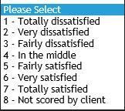
Fig. A

- Filling the Dialog+ Form

Fig. 1 to Fig. 7 shows an example of a Dialog form
- Date/Time- (This will be the assessment Date of the Dialog)
- Referral/Admission (when clicking the box , a list of all the referrals/Admissions will appear as shown in Fig. 1a)
- Is this a CPA Review (Choose either ‘Yes’ or ‘No’)
- Stage of Treatment (Choose one of the option from Fig. 1c)
- Service User Option (Choose one of the option as listed from Fig. 1d)
If the service user completely declines the assessment, this can be captured on the DIALOG + form. If the service user is willing to discuss the various PROMs and plan actions but they do not want to rate themselves or cannot rate themselves. In that scenario use option “8 – Not rated by client” against each of the areas.

All the 14 questions consists of the following sections
- Scores (Service User will decide from the score List in Fig. A)
- Does the service user want help? (Choose ‘Yes’ or ‘No’)
- Goals
- Actions

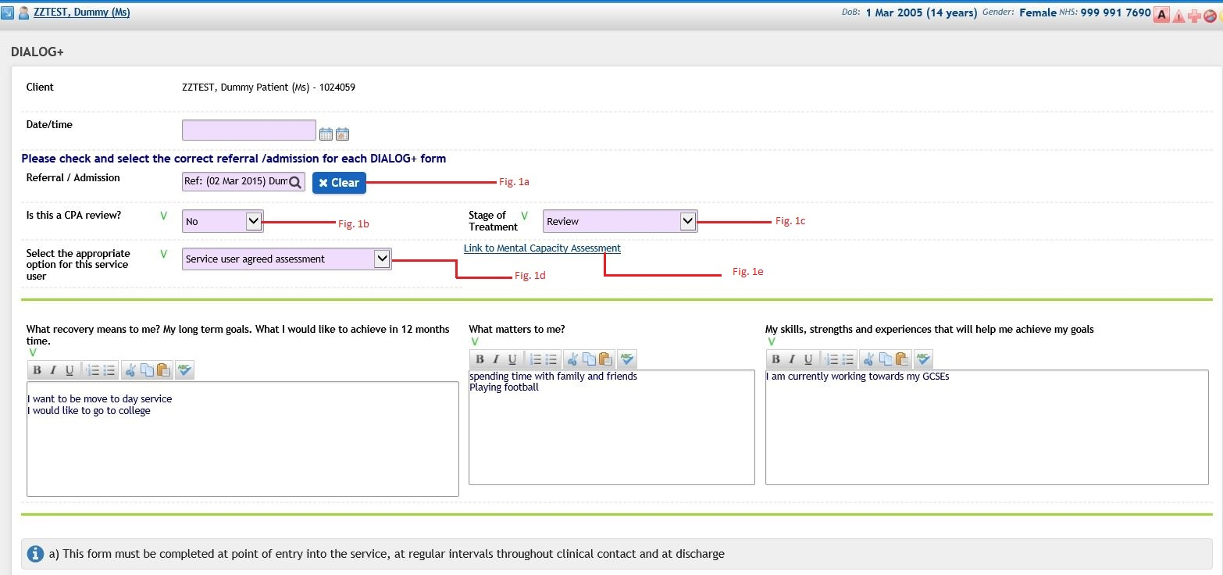
Fig. 1
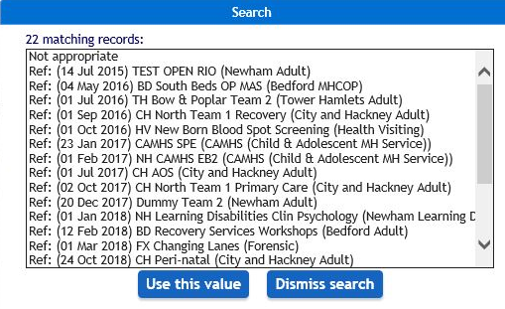
Fig. 1a (Link a Referral or Admission from the list)

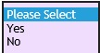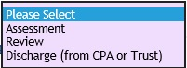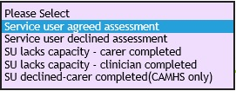
Fig. 1b Fig. 1c Fig. 1d

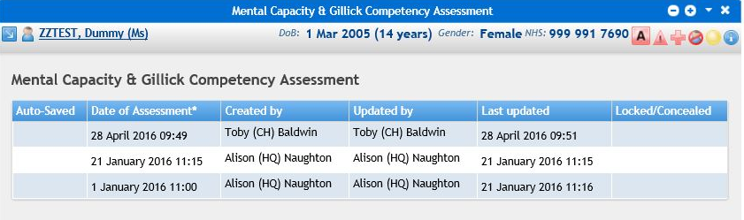
Fig. 1e (Link any Mental Health Capacity assessment from the list)

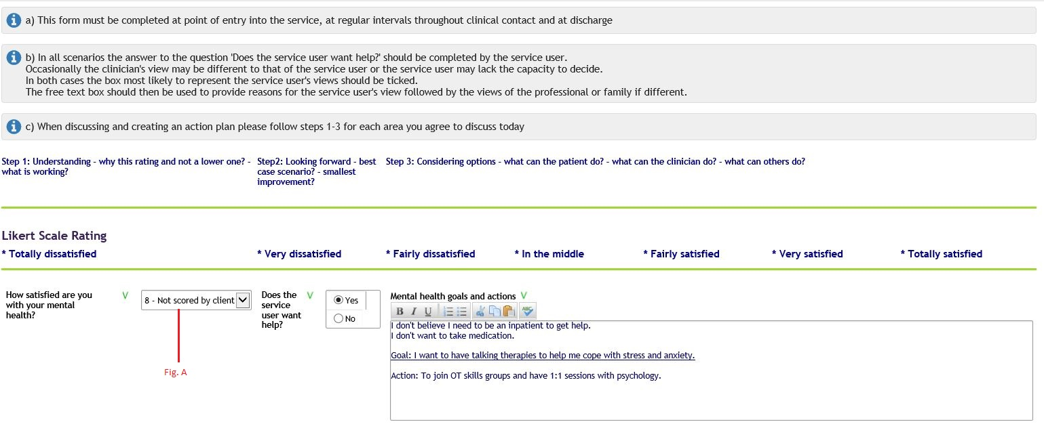
Fig. 2
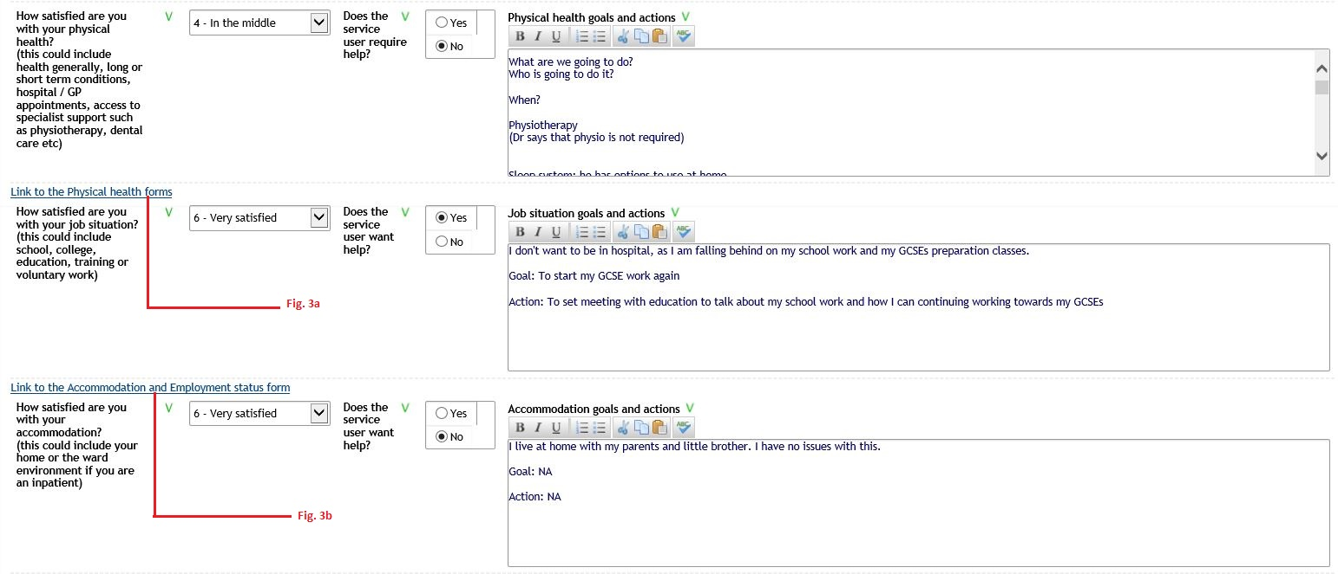
Fig. 3

Fig. 3a (Link any Physical Health Forms from the List)

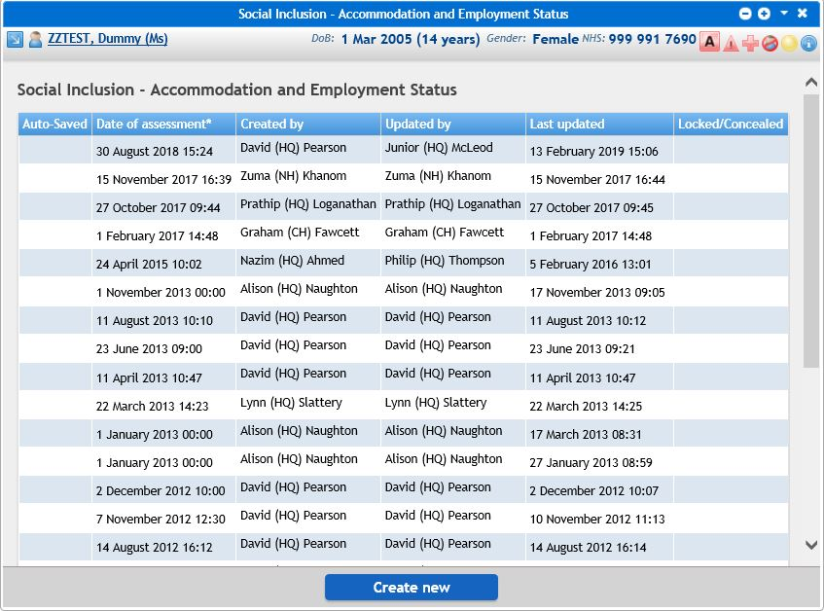
Fig. 3b (Link any Accommodation and Employment Status from the list)
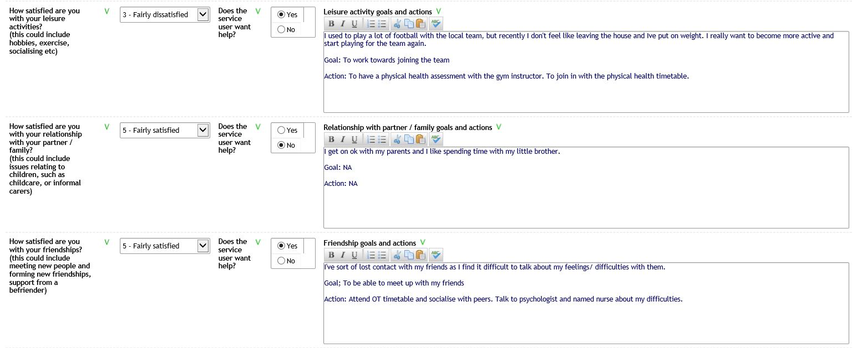
Fig. 4

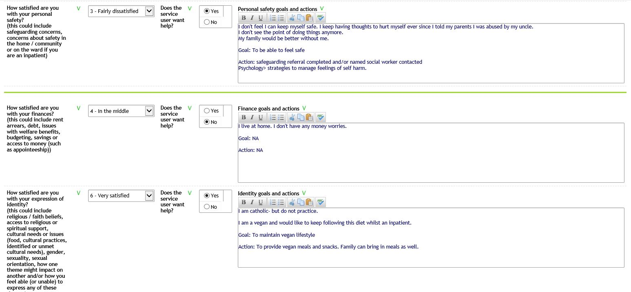
Fig. 5

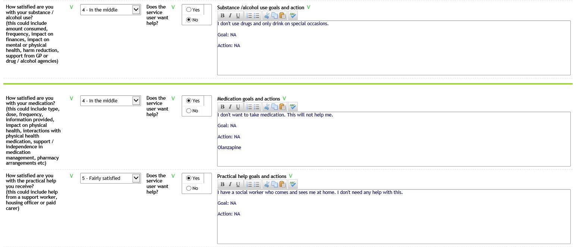
Fig. 6
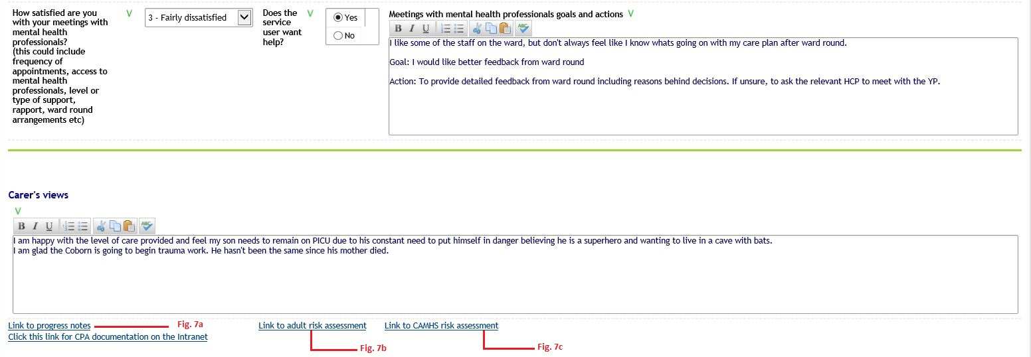
Fig. 7
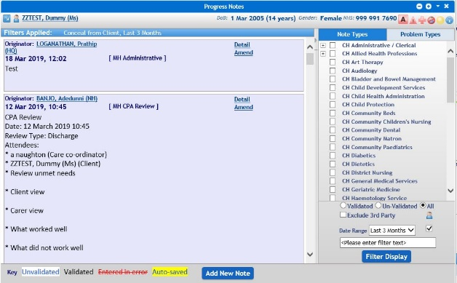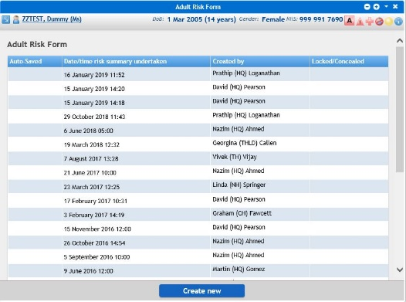
Fig.7a (Link any Progress notes) Fig. 7b (Link any adult assessment)
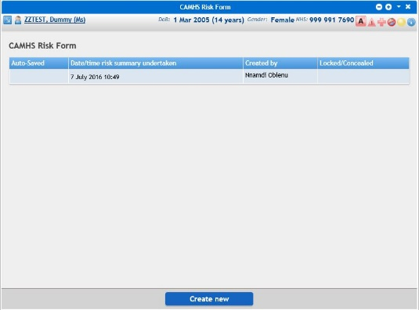
Fig. 7c (Link to CAMHS risk assessment)

