RIO MOBILE
QUICK USER GUIDE

Table of Contents
Logging on to RiO Mobile……………………………………………………………………………………………………..3
Appointment list view…………………………………………………………………………………………………………..4
Viewing a Patient Summary………………………………………………………………………………………………….5
Adding a Progress Note……………………………………………………………………………………………….…….6-8
Add an Alert…………………………………………………………………………………………………………………….9-11
Complete a Dialog Assessment Form…………………………………………………………………………….12-14
Complete a Lifestyle Form……………………………………………………………………………………………..15-16
Complete Safety Plan………………………………………………………………………………………………………….17

Logging on to RiO Mobile
- Launch RiO Mobile App.
- The RiO Mobile Login screen will be displayed.
- User credentials would have been entered and saved on the day of setup.
- To login, you will be required to use touch ID.
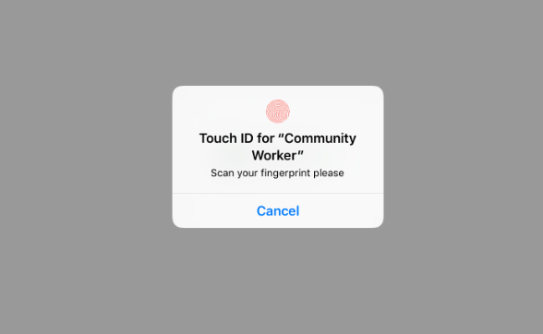
- If touch ID is not recognised, you will be required to enter your four-digit pin.
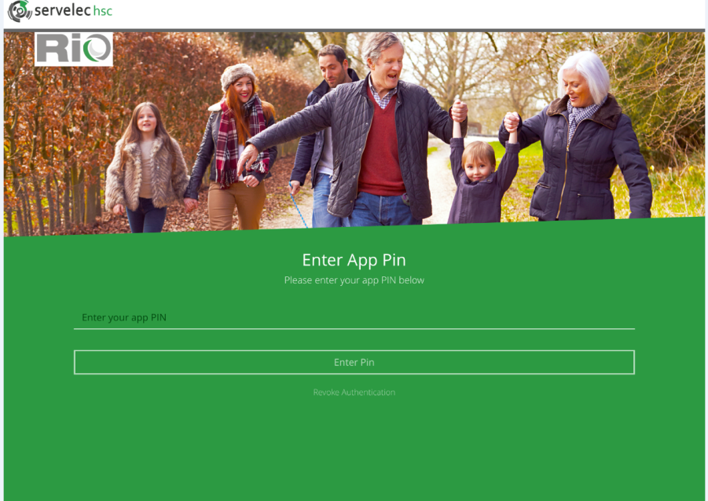

Appointment List View
- Once logged in, you will be presented with your appointment list for the day.
- By using the arrows either side of the calendar icon, you will be able to view yesterdays and tomorrows booked appointments. *Appointments must be booked in advanced on full Rio.

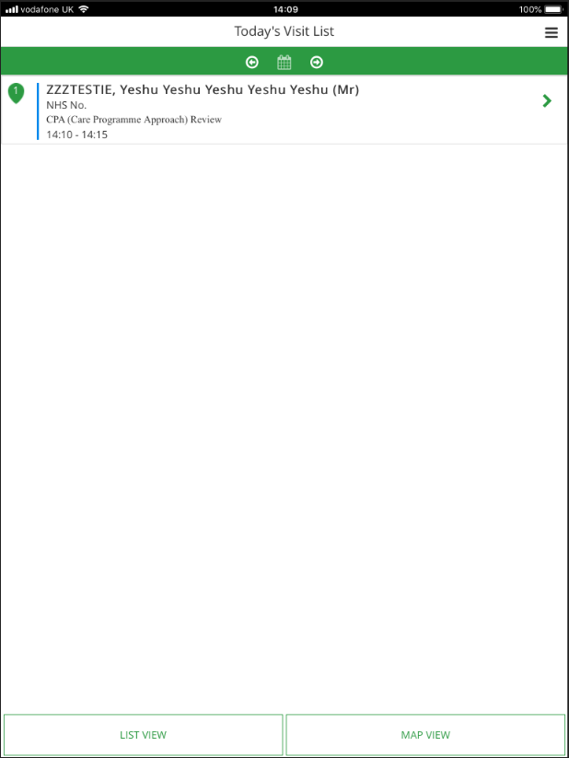

Viewing a Patient Summary
- To view a client’s patient summary, click green arrow on the right hand side of the appointment.
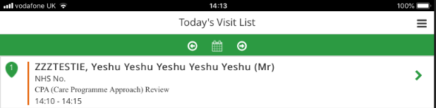

- Once selected, you will be directed to the patient summary page. Here you will be able to view current information on the client. It is within this screen that you will be able to start your visit.

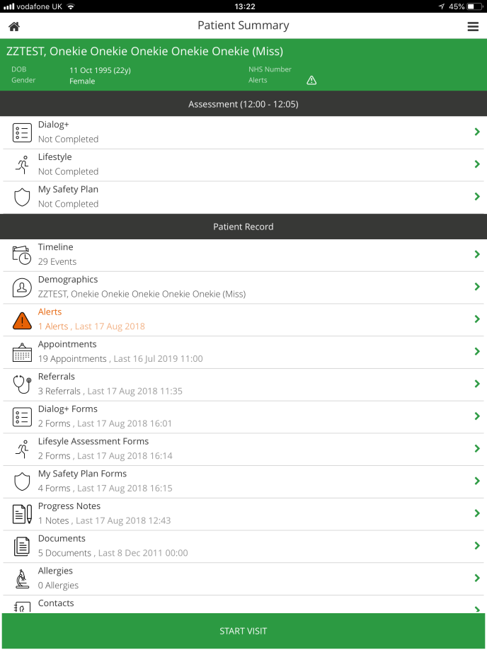

Add a Progress Note
- Click on ‘Add Note’.
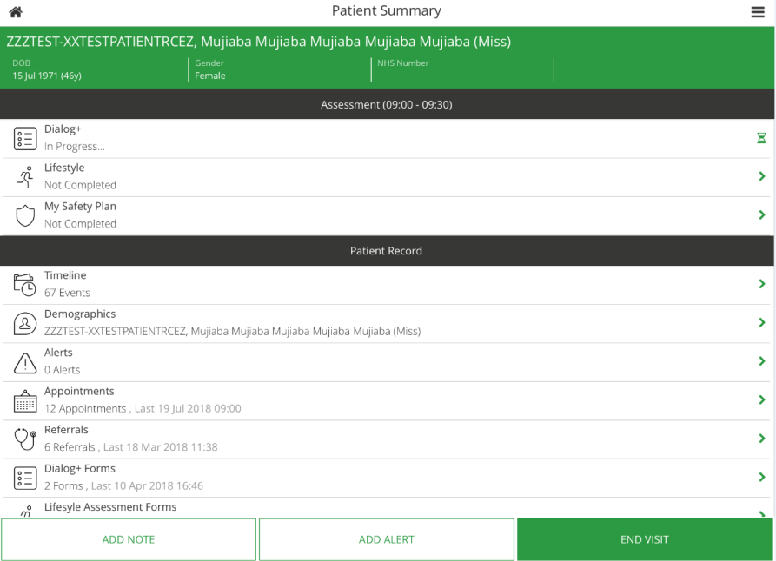

- Fill in the relevant information (including drop down lists and notes).
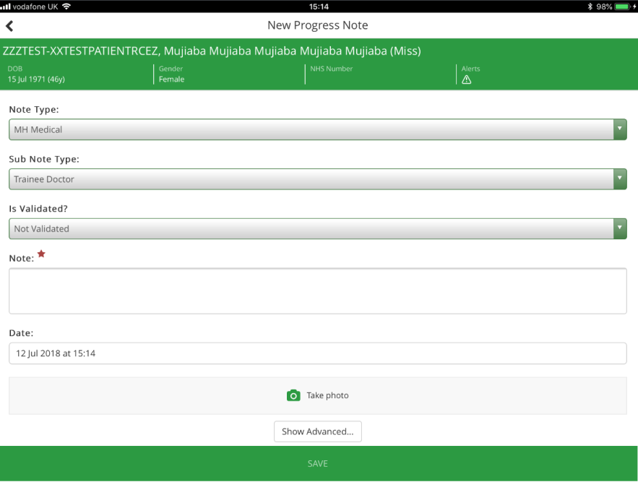

- Click on ‘Show Advanced’. This will provide you with more fields should they be required.
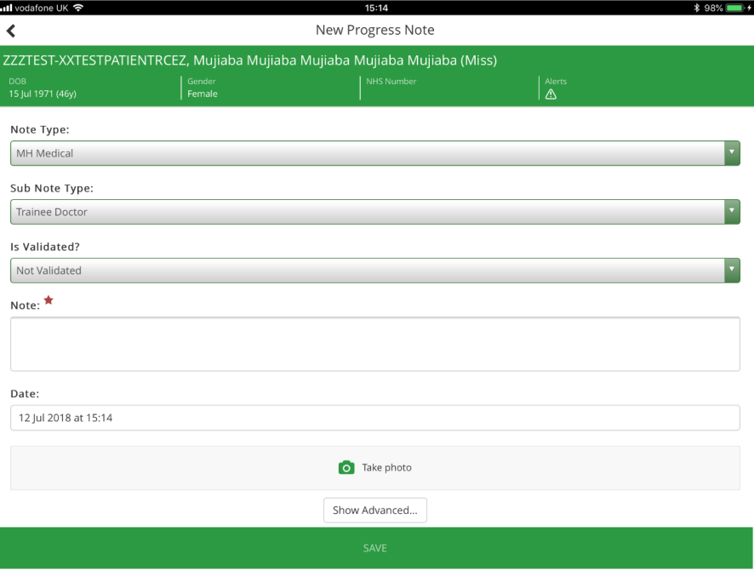

- To complete advanced entries.
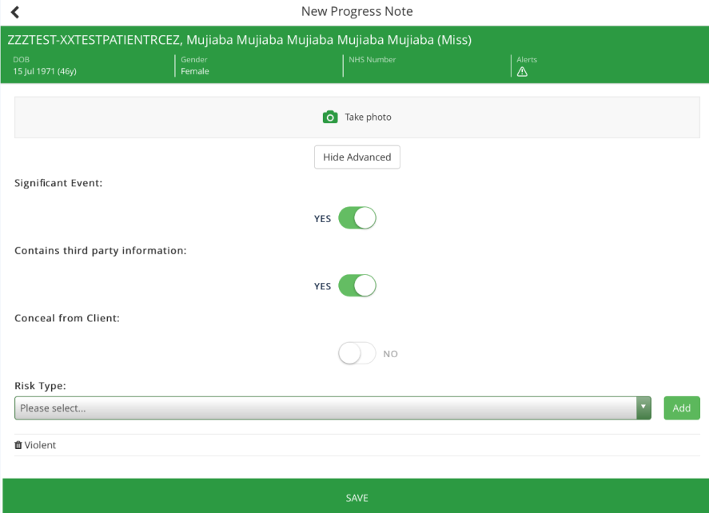

- To enter a risk type, select the ‘Risk Type’ by clicking on the drop down list and clicking ‘Add’.
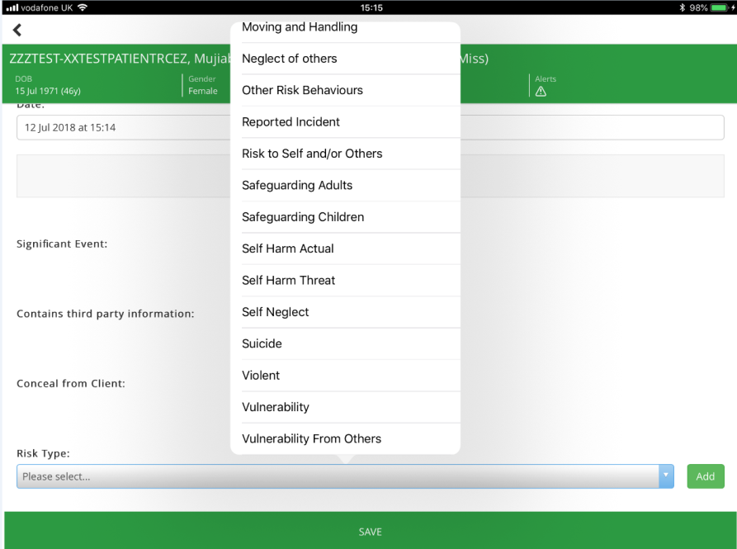

- Click ‘Save’. *On saving, the progress note will appear in the Patient Summary under Progress Notes.
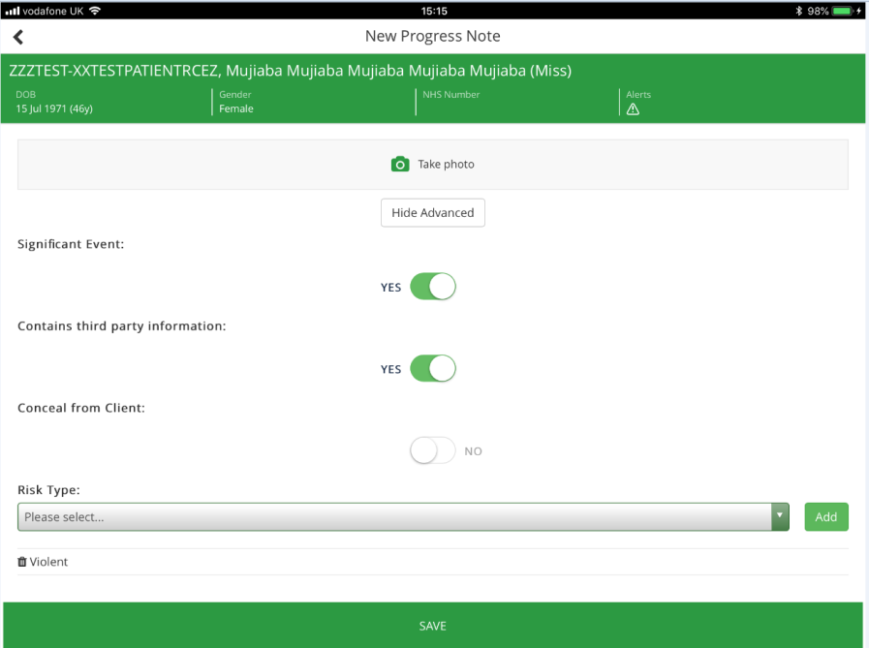

Add an Alert
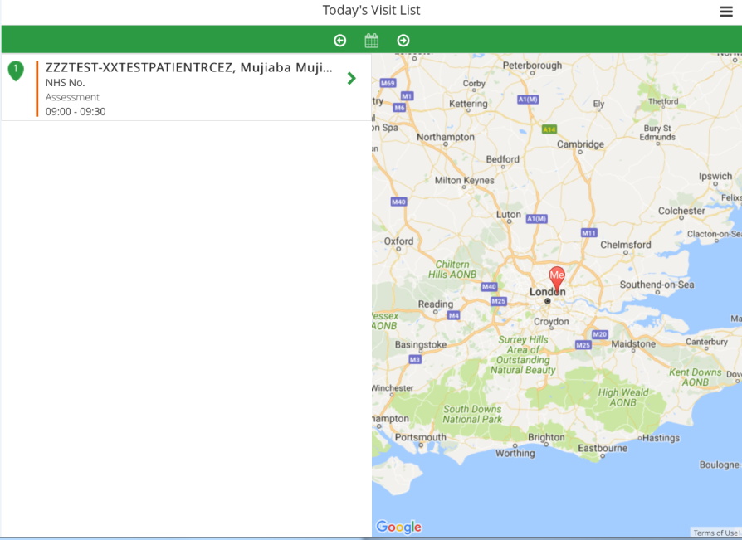
- Click on the patient you wish to add an alert to.

- Click ‘Add Alert’.

- Fill in the relevant information regarding the Alert then press ‘Save’.
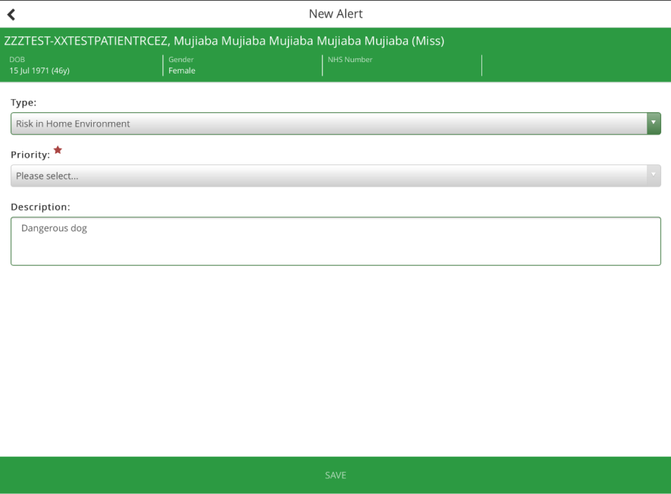

K

- Return to patient summary and click on ‘Alerts’.

- Check that the Alert has been added. Added Alerts should look like this.
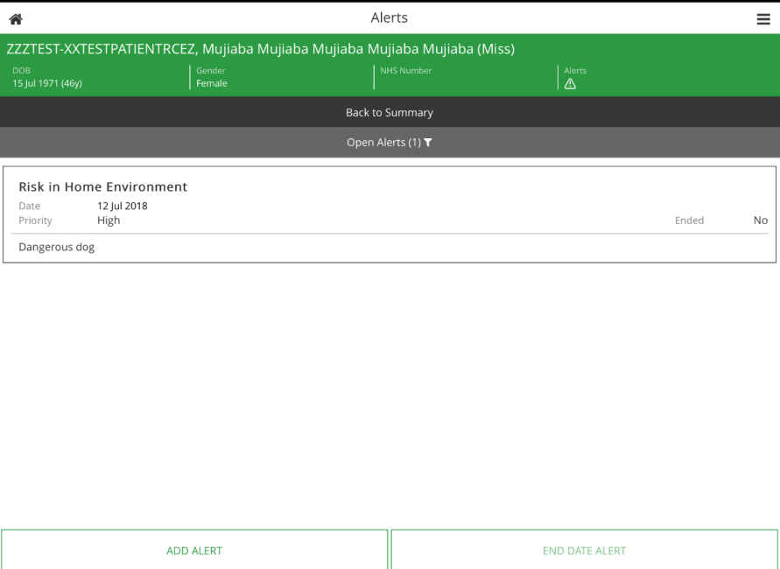

Complete a Dialog Assessment form
- Select the patient you wish to complete a dialog assessment for from ‘Today’s Visit List’.
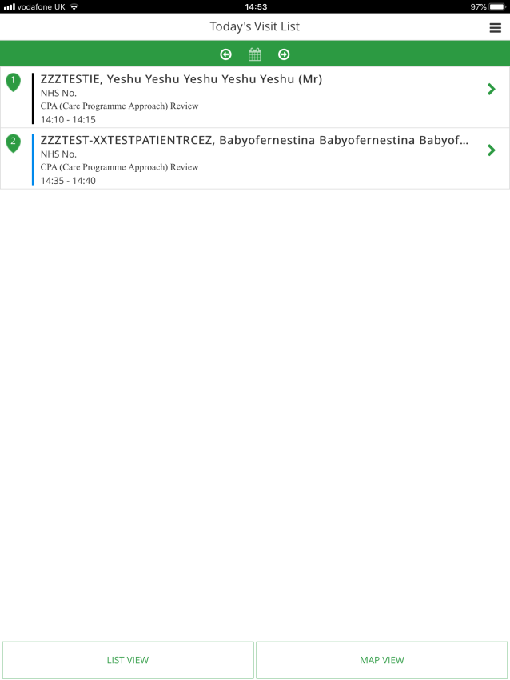

- Select start visit, then select the dialog tab to complete a Dialog Assessment.
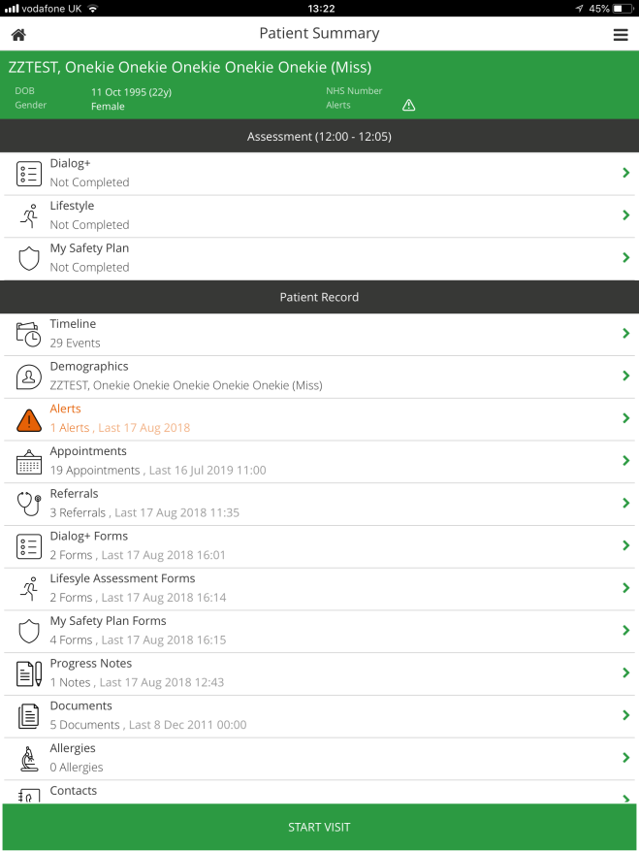
- On the Dialog Assessment page, complete all sections with the red asterix, including any relevant sections. Finish by selecting ‘Begin Form’.
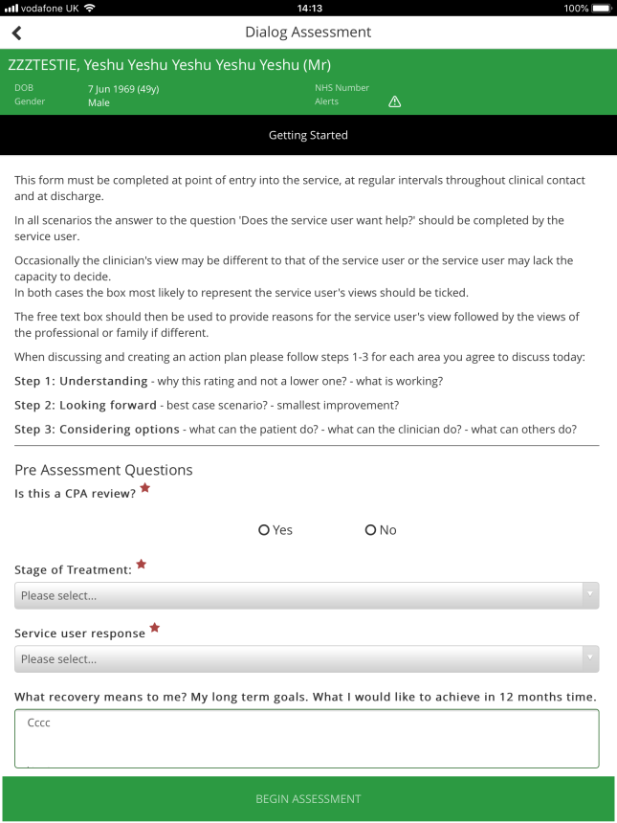

- You will be directed to the Dialog Form page. You are able to compare scores from previous DIALOG forms completed by using the drop down list and selecting a date.
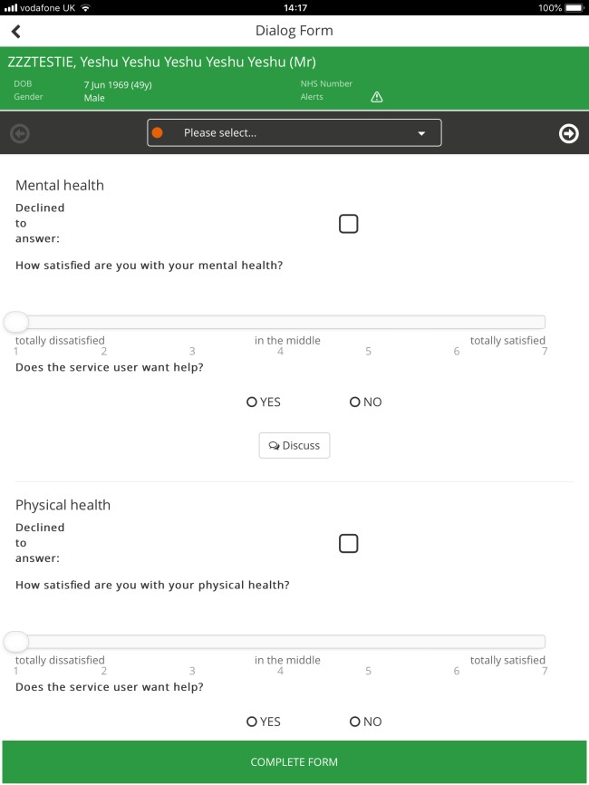
- The question ‘Does the service user want help?’ should be answered/completed by the service user.
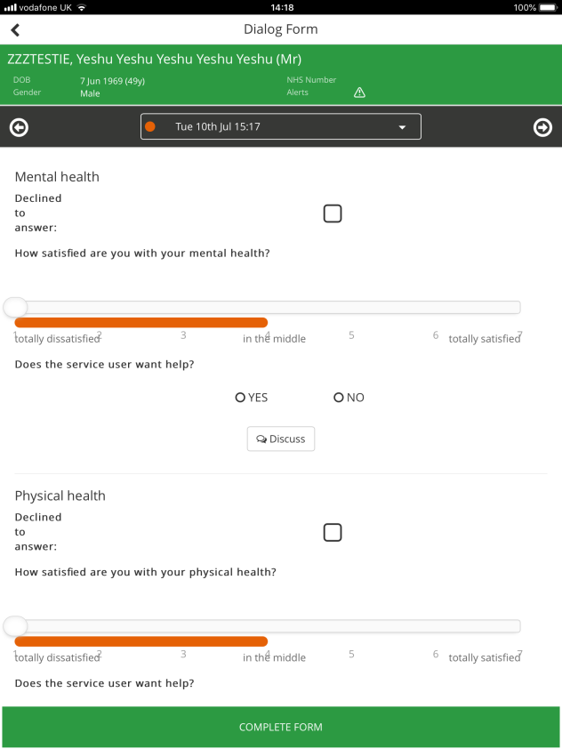

- Complete all relevant sections of the DIALOG form and click save. The form will show as completed on the Patient summary screen. Once saved you will not be able to go in and edit the form from mobile. You will be able to edit the form in full RiO.

Complete a Lifestyle Form
- Select ‘Lifestyle’ to complete with service user.
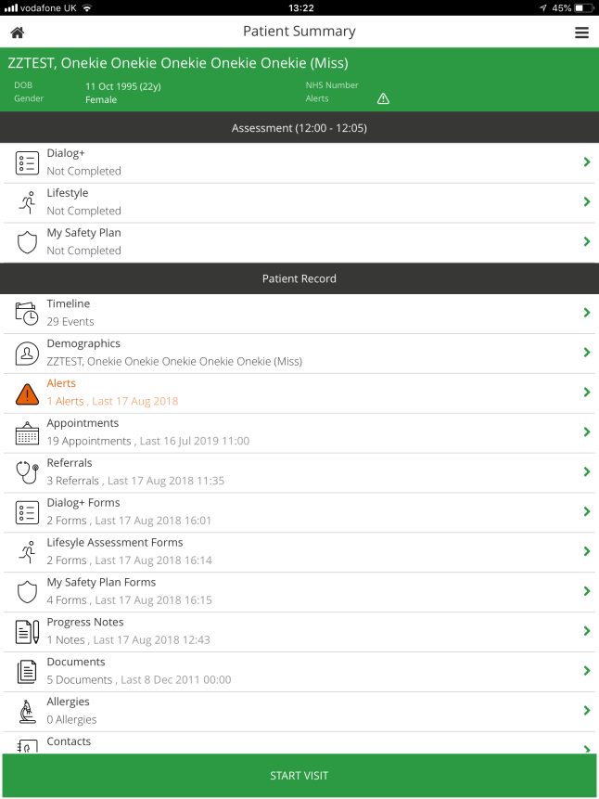

- Complete all questions and continue with next.
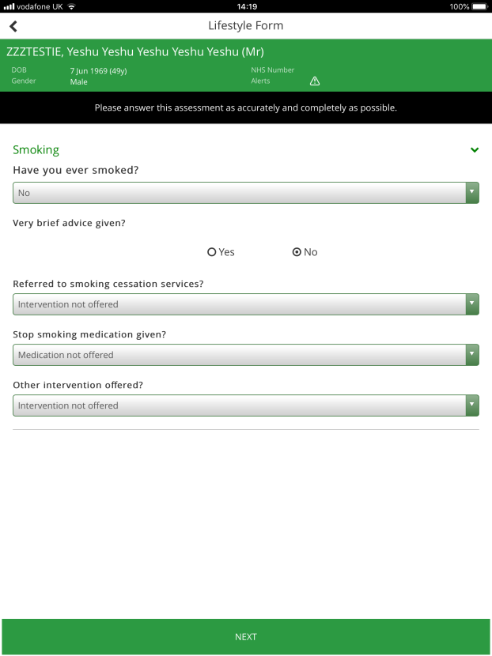
- Select ‘Save’ once completed.
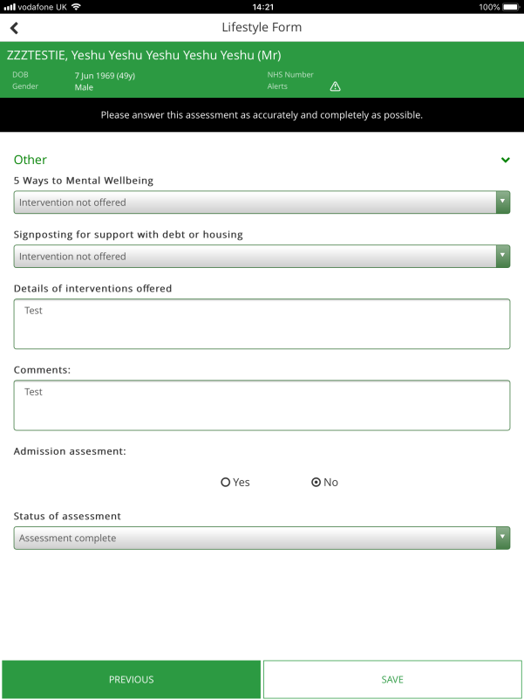

Complete My Safety Plan
- Click ‘My Safety Plan’.
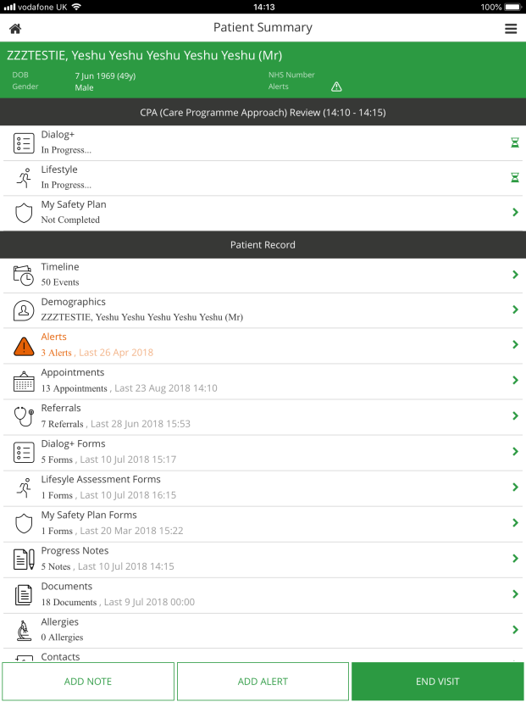

- Complete all sections and select ‘Save’ once completed.
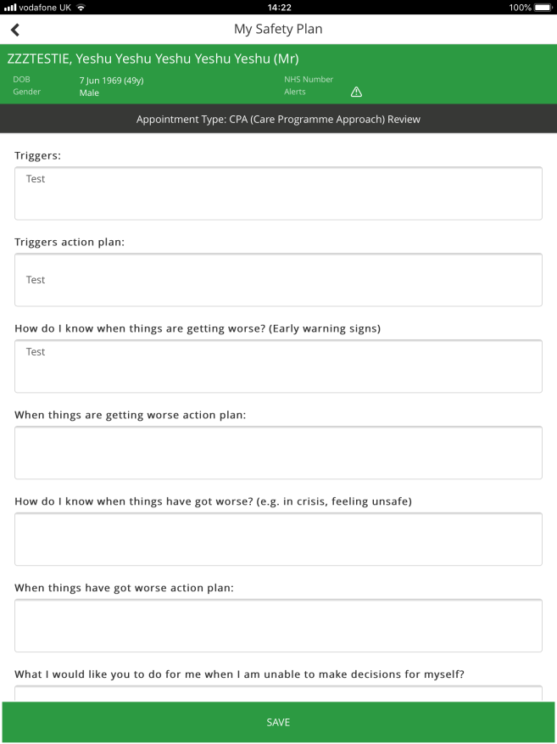
Outcome Appointments
- After you have completed all sections for your appointment you will be able to outcome the appointment for that client. ** You will not be able to add any further entries to the appointment via mobile once the appointment has been outcomed**

- Click ‘End Visit ’
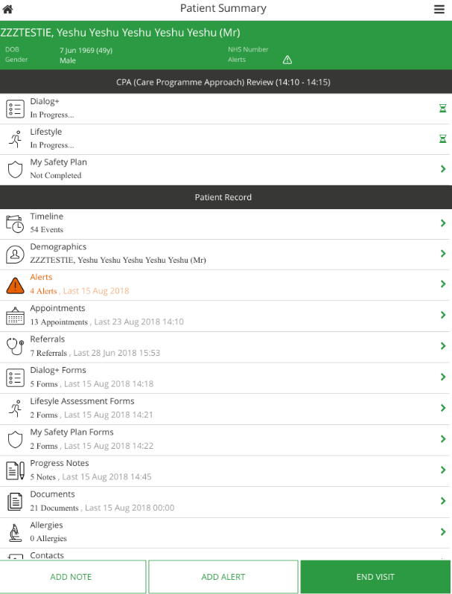

- You will be taken to the outcome screen and the appointment time will pull through. You will need to change the ‘seen at’ time and the ‘duration’ if different to the actual booked appointment.

- You will need to select and add an activity e.g. ‘Review’.

- You will need to select the outcome e.g. ‘Achieved’.

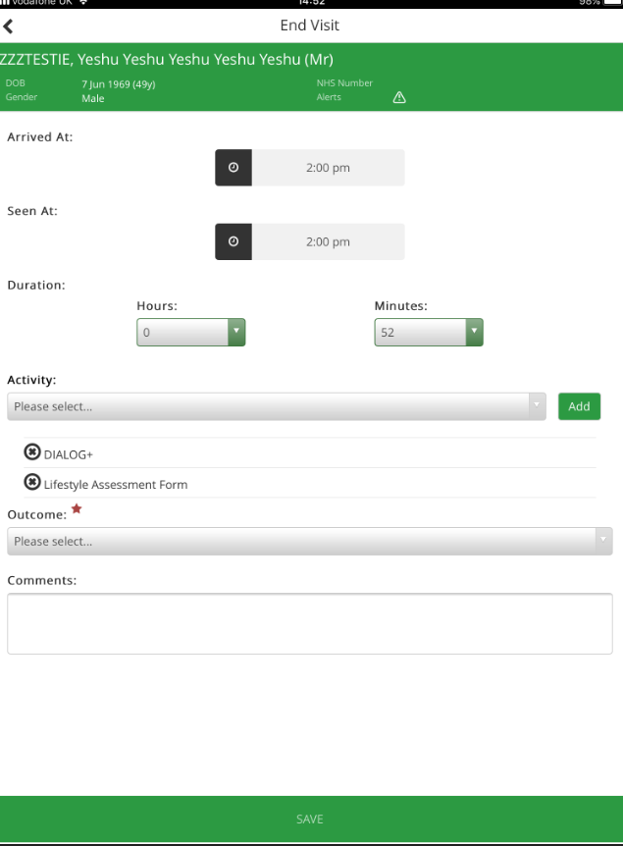
- Once all sections are complete select ‘Save’.

