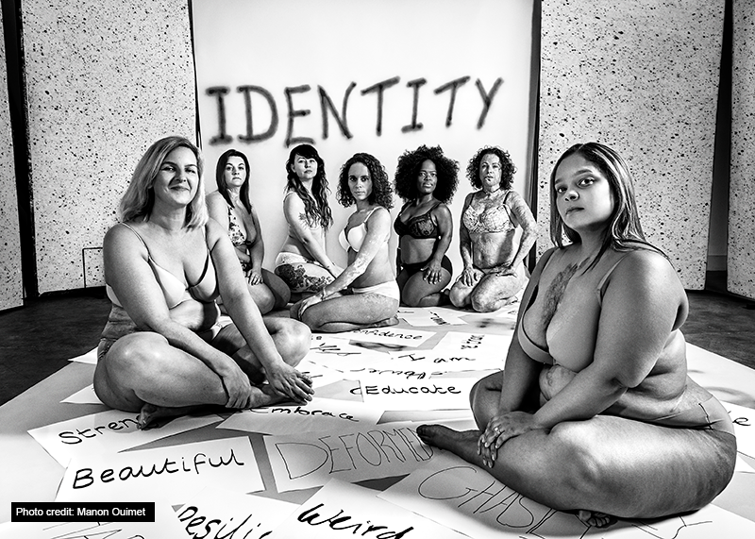
Mental Health Awareness Week 12-18 May 2019: Positive body image

Sylvia Mac, positive body champion and online voice of www.LoveDisfigure.com, explains her journey towards healthy self-esteem and the power of positive body image
At the age of 3, I was hospitalized from an accident at home falling into boiling water. After surviving life support, I went on to have numerous surgical procedures and operations. Every aspect of growing up in a society with a so called ‘perfect body image’ left me screaming inside. No matter how much support I received from family members, I could never love or appreciate my body and all the pain it was going through. When I hit my teens, one thing that stood out to me was body image and looking beautiful. My schoolfriends spent most of their time grooming themselves in front of the mirror and then there were the glossy magazines with flawless images. I recall hearing my mother’s friends say ‘thank God it’s not on her face’, but I converted those words to ‘the scars on her body are ugly and she is too’.
Every aspect of growing up in a society with a so called ‘perfect body image’ left me screaming inside.
The hospital consultants continually told my mother that I should stay covered up from the sun and as most burn victim or survivors know that this is all year round. Those words certainly had an effect on the rest of my life. Then there were all the hospital visits where my scarring was examined by student doctors. The only problem for me was that uncovering in front of a bunch of strangers really took its toll on my mental health. As I went into adulthood, I found myself feeling more and more anxious often suffering panic attacks believing that everyone knew I was burned. As a burn victim I found myself attracting undesirables who would take my insecurities for granted so I allowed myself to be abused both physically, sexually and mentally.

I finally hit rock bottom, drinking copious amounts of alcohol daily and then I met someone who fell in love with me and didn’t worry about my scars. We went on to have children together but no amount of love was going to undo years of self-hate. I began drinking heavily and often turning up at my children’s school intoxicated. Each day was different for me where I would either be happy and attacking everyone then the next day thinking of how I could end it all. I found myself trapped in a bubble of self-conscious thoughts and low self-esteem, lacking confidence in everything from school, work, relationships and society. Finally, in 2016 my grandson was born but I was still locking myself in my bedroom and crying every day. My GP asked that I try counselling but unfortunately it didn’t work for me. I began to research severe disfigurement on the body but each time I was presented with ‘facial disfigurement.’ I couldn’t understand why when I almost lost my life twice and suffered 3rd/4th degree burns to my body, it wasn’t being acknowledged. I understood how difficult it was for a person with facial difference to deal with this every day but I also knew that I was suffering too. My mental health was severely affected as well as dealing with lifelong physical pain.
I found myself trapped in a bubble of self-conscious thoughts and low self-esteem, lacking confidence in everything from school, work, relationships and society
Summer 2016, I was on holiday with my mother and noticed someone filming me. I dropped my sarong off my shoulders and my scarring was on display. We left the pool for the beach where my mother asked questions about my scars and I realised that she would have suffered PTSD, guilt and so much more. I took this moment to help change her life by strutting to the waters edge and uncovering my scars.
This was the beginning of my Love Disfigure journey to body acceptance and helping support others online come to terms with their visible or hidden differences. I shared an online video reveal and spoke about what I endured throughout my life. I set up a Facebook group to encourage people who look different both facially and/or BODILY to embrace the way they look. I wouldn’t want anyone to go through years of depression and suicidal thoughts as I did. It wasn’t long until I received worldwide messages and quickly changing other people’s life’s through my campaigning. I was even more surprised to hear from people who had all types of conditions including bipolar, depression and even stretchmarks and wanted to become involved. Now is the time for us all to become more diverse and inclusive in this body obsessed society that we live in through educating and campaigning.
I wouldn’t want anyone to go through years of depression and suicidal thoughts as I did.
It might have taken a lifetime to get here but it’s all been worth it helping others to accept the way they look. I now campaign for more diversity within the fashion industry, tv and film industry and above all society. We are all survivors and should be proud of our bodies and how amazing they are regardless of how they look.
Good Thinking is working with Sylvia and other people who manage online communities to develop resources that will equip them to support the wellbeing needs of their community members, as well promoting their own good mental health. If you’d like to be part of the project, contact info@good-thinking.uk
Join the conversation @goodthinkingUK on Twitter
Visit Good Thinking to explore tools and resources that can help you on your personal journey.
Learn more about Good Thinking
About the author
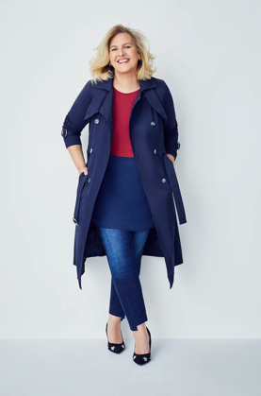
Sylvia Mac is the founder of Love Disfigure which was born out of a need to raise awareness and support those living with disfigurement & differences. At the age of 48, Sylvia dared to bare her scars for the first time. In December 2018 she was awarded the 1063rd Point of Light award with a personal letter from Prime Minister Theresa May and can be found on Downing Street website. Sylvia has recently been honoured by Mayor of London on the Hidden Credits page for people who selflessly give their time to others. Sylvia has also won a Beautiful Survivor of the World Award. Get involved with Love Disfigure’s online at Instagram @love_disfigure, Twitter @LoveDisfigure and via Love Disfigure’s website https://www.lovedisfigure.com/ to find out more.

