

Children and Young People Health Partnership

Southwark and Lambeth

# Background

The Children and Young People Health Partnership (CYPHP) is a local partnership of Commissioners and Providers, Parents, Carers, Young people, and Researchers committed to changing the way healthcare is delivered for the 120,000 children and young people (CYP) in Southwark and Lambeth. CYPHP aims to promote sustainable and scalable change by testing and proving the benefits of new models of care and approaches to healthcare delivery.

# Action

The programme has been co-designed with local children, young people, parents, clinicians and other providers and commissioners across the local health economy to ensure that CYPHP addresses areas of real need. CYPHP is designed to:

* Improve child health
* Improve the quality of children’s health and care
* Make the system easier to access and more equitable for CYP
* Create a learning healthcare system – building an evidence base to enable continued improvement of CYP services

# Outcomes

The CYPHP model will help create a wider more supportive network around the child to improve health outcomes and healthcare quality:

**At home** – Children and young people will feel more confident in managing their condition because they will have a more detailed and effective asthma care plan completed with a CYPHP specialist nurse or GP. They are happy that their parents have stopped smoking after being offered smoking cessation advice following a CYPHP nurse-led clinic.

**At school** – Children and young people will feel more confident that their teachers and school nurses understand and are able to help manage their condition following training delivered by the CYPHP specialist nurse.

**When interacting with primary care** – Children and young people feel more confident in their interactions with GPs and Practice Nurses and they in turn feel better supported through the access to specialised paediatric support that CYPHP brings including co-designed guidelines based on NICE but available on local GP systems and linked to referral support; in-reach clinics delivered by a GP-Paediatrician team; and a Paediatric consultant hotline for urgent support. CYPHP is holistic, so physical and mental health is part of the same package. CYPHP pharmacists will ensure that medicines are optimally prescribed and used. YP also feel more welcome at their GP practice which is now a “CYPHP YP Friendly Practice”.

**At the hospital emergency department –** Children and young people who attend frequently will prompt a trigger through the CYPHP Learning Healthcare System, and CYPHP specialist nurses will offer extra support if and as needed.

**The CYPHP model put the needs of local children who have asthma at the centre of our whole system approach to Long-Term Condition care:** 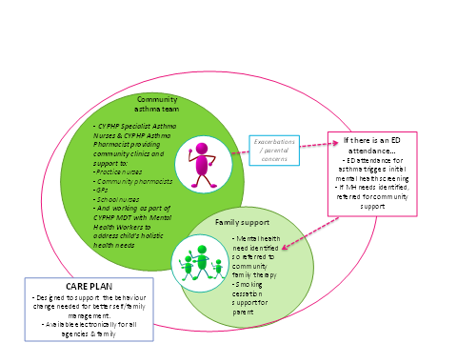

# Contacts

*For more information please contact: Azhar Saleem (CYPHP Long-term Condition Clinical Lead,* [*azhar.saleem@nhs.net*](mailto:azhar.saleem@nhs.net)*) or Barbara Rafferty (CYPHP Project Manager,* [*Barbara.Rafferty@gstt.nhs.uk*](mailto:Barbara.Rafferty@gstt.nhs.uk)*)*