

C3 – Child Health Care Closer to HomeClinic

Your GP has referred you to the new C3 clinic at Innovations Children’s Centre in Ovenden.

This leaflet explains about the C3 clinic and what you should expect

**What is C3?**

C3 is a new clinic for children and young people who live in your area. Instead of going to the hospital you will see a doctor or nurse who are specialists in child health. In the clinic there will be a Consultant Paediatrician, Specialist GP, Paediatric Nurse Practitioner and Children’s Community Nurse. On the day you will be seen by the most appropriate person depending on your/ your child’s need but also receive ongoing support from the community nurse to help you look after your child’s health condition. The service will also provide you with the right information and support to help you manage your own/ your child’s health condition.

**Why have we designed** C3**?**

When we spoke to children, young people and their families we were told that you wanted services closer to where you live at times that suit you best. This is why we are setting up the C3 clinic in Ovenden from 4pm in the afternoon into the early evening.

If you have any questionsabout your appointment for the C3 clinic then please phone01484 342872

**The** C3 **team look forward to meeting you**.

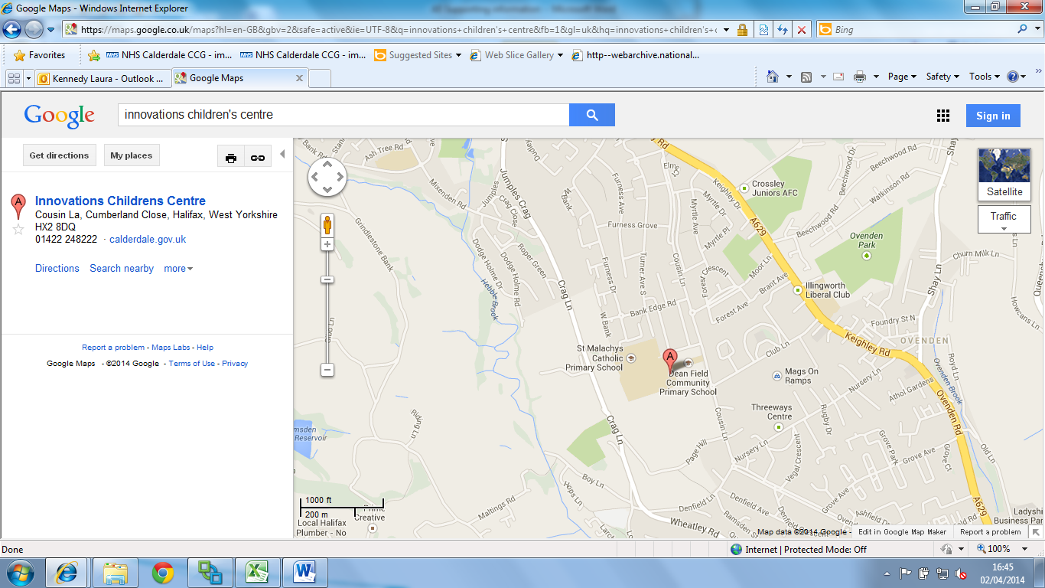

**Innovations Children’s Centre**

**Ovenden**

**Halifax**

**HX2 8DQ**

(Located in the grounds of Dean Field Community Primary School, Ovenden)

**Bus route:**521 Halifax - Illingworth Circular (Sky Blue Line) Via Ovenden Way - Cousin Lane

**On-site parking available**