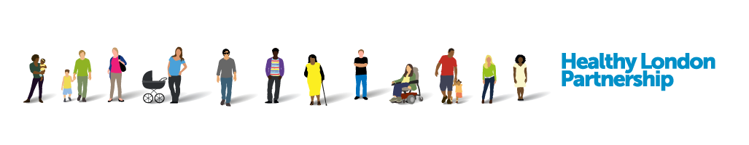



**An organisational pledge for schools:**

**Improving the treatment and management of asthma in children and young people**

**August 2017**

Asthma is the most common long term medical condition affecting children and young people (CYP). 1 in 10 CYP are affected by the condition meaning 240,000 CYP have asthma in London. Many have badly managed asthma – to the extent that 4,000 are admitted to hospital with asthma every year, and 170 have such a severe episode that they require admission to intensive care.

At the worst end of the spectrum around 12 children die of this disease in the capital every year. Poorly controlled asthma affects every aspect of children’s lives – their ability to learn, enjoy time outside school with friends or take part in sport. It affects their time with their families and how they sleep.

There are tools and guidance that exist to help healthcare professionals and others treat and manage asthma and support patients to self-care. We do not have to wait for new medicines or a cure for asthma: we need to educate and support our workforce to use these tools to achieve improved outcomes. However, making a significant change requires agreement and coordinated effort.

By signing the “pledge” in this document, this represents an agreement from those in key system leadership positions within organisations to implement simple measures to improve care and management of children and young people with asthma. In addition, in recognition of the significant role played by air pollution in triggering asthma attacks, we are asking NHS organisations to commit to reducing their contribution to air pollution.

To provide support for this, we have produced a toolkit [*NHS Trusts: Air pollution reduction toolkit*](https://www.healthylondon.org/latest/publications/asthma-air-pollution-toolkit). This describes simple and free changes NHS organisations can make to reduce their contribution to London’s air pollution.

The organisational pledges form part of a wider #AskAboutAsthma campaign being run from **11th to 22nd September**. This is a campaign to raise awareness of simple measures that should be taken to manage all CYP with asthma. It aims to ensure that existing asthma standards and ambitions are met across London and that no more children die from preventable asthma attacks.

In addition to having organisational pledges, individuals will be showing their support for the campaign by describing their own contribution to improving asthma care through the #MyAsthmaPledge initiative.

Both organisational and individual pledges to support the campaign will be visible on the Healthy London Partnership [My Asthma Pledge](https://www.healthylondon.org/children-and-young-people/my-asthma-pledge) page.

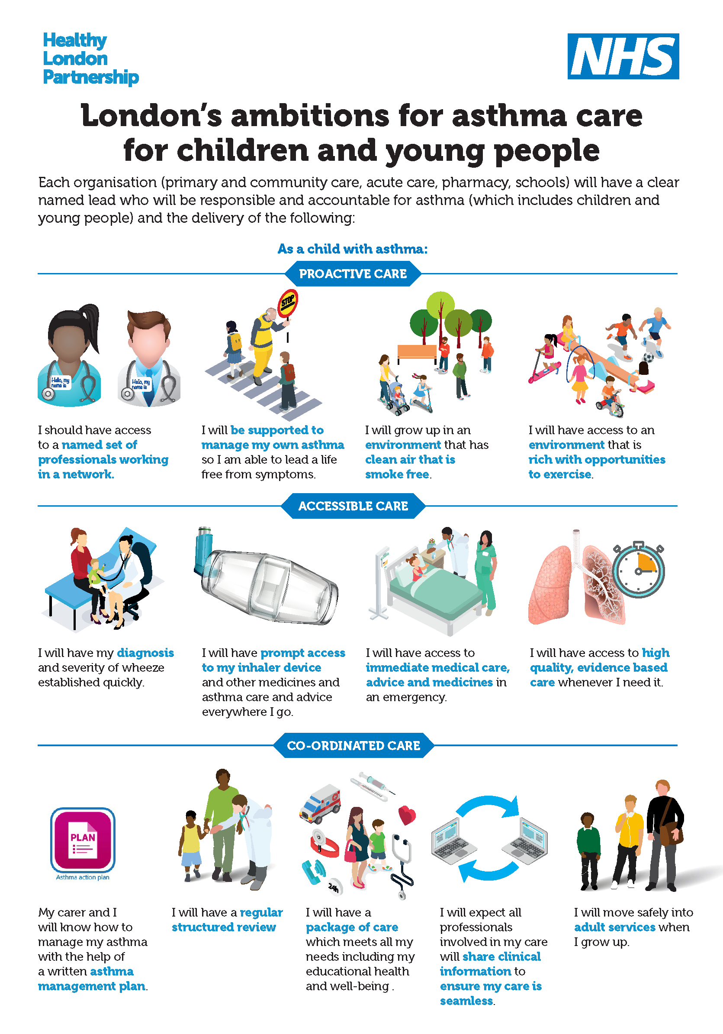

**Key facts (reference** [**asthma case for change**](https://www.healthylondon.org/children-and-young-people/london-asthma-toolkit/primary-and-community-care/evidence-and-resources)**)**

* London has a higher rate of illness and death in children and young people because of asthma compared to other European countries
* It is one of the top three causes of emergency admission to hospital (4,000 in London each year.) 75% of these admissions are avoidable by implementation of simple interventions
* Nearly half of these children have had an asthma attack in the previous year and 30% have had daytime symptoms in the previous week, but only a fraction of these have a personalised asthma plan on how their asthma should be managed
* 170 children were admitted to intensive care in 2016/17, with an average length of stay of 3 days. The represents a spend of over £1million on intensive care for this population
* Nitrogen dioxide, particulate matter and other forms or air pollution are known triggers for asthma and poor health more widely, particularly in children.
* Around 12 children die of asthma in London each year; 90% of these deaths are preventable. These children should have gone on to lead full and productive lives.

**The need for action in London**

As the most common long term condition in children asthma accounts for one in five consultations with a GP. While London has pockets of world class services for children and young people with asthma, there is unacceptable variation in services, outcomes and patient experience between and across boroughs and from year to year. Hospital admission for asthma is a proxy for failure of asthma management and acts as an indicator of poor symptom management. Emergency admissions for asthma show a threefold variation across boroughs in London. Socioeconomic status, ethnicity and levels of air pollution are all factors in why need and provision may differ, however, variation due to differences in care quality, efficiency and equity needs to be considered and reduced.

**The London asthma standards**

Healthy London Partnership has developed a set of [ambitions](https://www.myhealth.london.nhs.uk/sites/default/files/London_asthma_ambitions_for_children_and_young_people.pdf) for how asthma care should be delivered across the city. [The London asthma standards for children and young people](https://www.healthylondon.org/latest/publications/asthma-standards) bring together these ambitions for London with national and local standards.

The online [London asthma toolkit](https://www.healthylondon.org/children-and-young-people/london-asthma-toolkit/primary-and-community-care/evidence-and-resources) is available to support healthcare professionals, commissioners, schools, parents, carers, children and young people in London implement the asthma standards for children and young people. It has a specific section devoted to schools. The toolkit provides practical resources for all those involved in caring for children and young people with asthma and can be accessed anywhere, at any time.

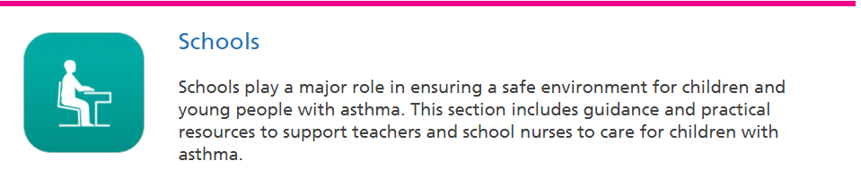

**Bringing about change – #AskAboutAsthma**

There are **three very simple measures** which if used consistently for all CYP with asthma would have a massive impact on quality of life for these children and young people.

1. The use of a [**written asthma action plan**](https://www.healthylondon.org/children-and-young-people/london-asthma-toolkit/hospital-care/action-plans) drawn up between a clinician and asthma sufferer means people are four times less likely to have to go to hospital for their asthma. Only 28 – 48% of CYP with asthma in London have an asthma plan.
2. Ensuring every child or young person (and their families/carers) understands how to [**use their inhaler effectively**](https://www.healthylondon.org/children-and-young-people/london-asthma-toolkit/pharmacy/inhalers)**.** Less than ¾ of CYP have any form of instruction in how to use their inhalers meaning they may not be getting the full benefit of their asthma medication.
3. An [**annual asthma review**](https://www.healthylondon.org/children-and-young-people/london-asthma-toolkit/primary-and-community-care/review)which will ensure those with asthma have effective regular review of their condition and management

The #**AskAboutAsthma** campaign encourages CYP and their families to ask for these three simple effective interventions to help them control their asthma. In addition, it identifies questions that healthcare professionals should ask of those CYP with asthma to help optimise care

**Bringing about change - system-wide pledges**

In addition to the three simple measures outlined above, improving outcomes for asthma is about leadership, accountability and training in every aspect of asthma care. It requires commitment to an integrated approach and outcomes need to be meaningful and based on meeting the asthma standards.

By aligning our efforts, children and young people with asthma and their families would be diagnosed earlier, would receive better management and experience improved quality of life. There would be less illness and fewer deaths associated with asthma, with less burden on the child, family and NHS as a result.

This agreement is aimed at everyone involved in the treatment and management of CYP:

* GP Federations
* Pharmacists
* Acute trusts (providing emergency and routine care)
* Specialist care organisations
* Commissioners
* Schools

We ask these groups to sign a pledge to improve the care and management of children and young people with asthma through supporting and working towards achieving the asthma standards relevant to them.

As part of this pledge, we ask those who sign up to agree to reduce their own contribution to air pollution that is a significant contributor to asthma in our city. Suggestions of how to do this can be found in “[Strengthening the NHS contribution to improved air quality in London”.](https://www.healthylondon.org/latest/publications/asthma-air-pollution-toolkit)





**An organisational pledge for schools:**

**Improving the treatment and management of asthma in children and young people**

Schools play a major role in ensuring a safe environment for children and young people with asthma.

Having asthma has implications for a child’s schooling and learning. It impacts on care given within schools and early year’s settings, and appropriate asthma care is necessary for the child’s immediate safety, long-term well-being, and optimal academic performance.

Whilst some older children may be fully independent with their condition younger children, children with learning difficulties or those newly diagnosed are likely to need support and assistance from school staff during the school day, to help them to manage their asthma in the absence of their parents.

The 2010 Children, Schools and Families Act and the Children and Families Act 2014 introduce a legal duty on schools to look after children with medical conditions. This is inclusive of children with asthma and it is therefore essential that all school staff and those who support younger children have an awareness of this medical condition and the needs of pupils during the school day.

To ensure clinical leadership for asthma care, the school should have an **identified lead for asthma** or long term conditions, who helps to develop excellent streamlined processes and best practice for supporting the children within their school.

The [London asthma ambitions](https://www.healthylondon.org/sites/default/files/London_asthma_ambitions_for_children_and_young_people.pdf) describe system wide goals [The London asthma standards for children and young people](https://www.healthylondon.org/latest/publications/asthma-standards) bring together the aspirations for London, the NICE Asthma standards, British Thoracic Society guidelines and a number of other key resources

By signing this pledge your organisation is committing to

* implementing the London asthma ambitions and standards for acute trusts
* taking steps towards improving air quality.

Please sign the [pledge document](https://www.healthylondon.org/children-and-young-people/my-asthma-pledge) online or photocopy Appendix A. You are also encouraged to take a photo and tweet us @healthyLDN about your pledge.

The [London asthma standards](https://www.healthylondon.org/children-and-young-people/london-asthma-toolkit/pharmacy) relevant to schools are:

All organisations/services must have a named **lead responsible and accountable for asthma** (which includes children and young people). They must also all meet the organisational standards (No 1-7) and patient family and support information provision and experience (No 9-13). Please also the see the workforce education and training standards that are applicable to the setting (No 38-42)

|  |  |
| --- | --- |
| **No** | **School Standards** |
| 11 | CYP and their families receive **sufficient information, education and support** to encourage and enable them to participate actively in all aspects of their care and decision making.  This means information is tailored to their needs in an accessible format (eg written information may use pictures, symbols, large print, Braille and different languages) throughout the care pathway extending into schools and community settings. |
| 17 | Clear effective **partnership arrangements are in place between health, education and local authorities** for management of children and young people with asthma within primary and secondary schools ([Asthma friendly schools](https://www.healthylondon.org/children-and-young-people/london-asthma-toolkit/schools/asthma-friendly) programmes).  This includes the adoption of government policy on emergency inhalers and early years settings such as children’s centres having access to education programmes for the wheezers. |
| 18 | CYP have an **individual healthcare /action plan** in place.  The school has in place:   * [**Register**](https://www.healthylondon.org/sites/default/files/Example%20asthma%20register%20for%20schools.xlsx) of all CYP with asthma. * [**Management plan**](https://www.healthylondon.org/sites/default/files/School%20asthma%20plan.docx) for each child. * **Named individual** responsible for asthma in school. * Policy for inhaler techniques and care of the CYP with asthma. * [**Policy**](https://www.myhealth.london.nhs.uk/system/files/HLP-Schools%20asthma%20guide%20May%202016.pdf)regarding emergency treatment. * **System** for identifying children who are missing school because of their asthma or who are not partaking in sports / other activities due to poor control |
| 39 | Children and young people have contact with healthcare professionals who have received **appropriate training and ongoing education** in paediatric asthma with appropriate updating at least every three years, including access to a specialist paediatric nurse with asthma diploma level training and CPD in paediatric asthma. This includes primary care and the wider MDT such as pharmacists, health visitors and **schools.**  At least one practice nurse in every practice or **someone in every school is trained in managing asthma** (ie holds a recognised certificate of competence, such as an asthma diploma), and has experience in supporting children with long term conditions |

The [London asthma toolkit](https://www.healthylondon.org/children-and-young-people/london-asthma-toolkit/hospital-care) contains numerous resources to support [schools](https://www.healthylondon.org/children-and-young-people/london-asthma-toolkit/schools) in implementing the standards.

Please see the schools guide [here](https://www.healthylondon.org/children-and-young-people/london-asthma-toolkit/schools/print-version)



|  |
| --- |
| **#AskAboutAsthma** |
| **Schools should make sure their staff:** |
| ASK who the school asthma lead is  ASK if they have an up-to-date school policy and register of children with asthma  ASK if they have a management plan for each child and a named contact lead within the school  ASK if they have an emergency supply of inhalers on site  ASK if their staff have been trained and know what to do in an emergency |

