ASTHMA ASSESSMENT SERVICE
USER GUIDE
Sonar Informatics
Asthma Assessment Service – User Guide
Version 1.0

08th May, 2017
- Service Home Page

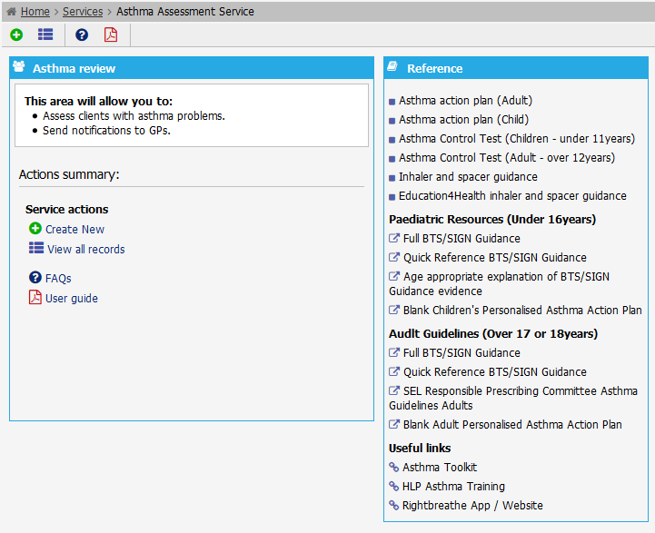

Service reference documents
And
Useful links
Service menu
And
Actions

- Submit a new record (New assessment)

  - Search for an existing patient

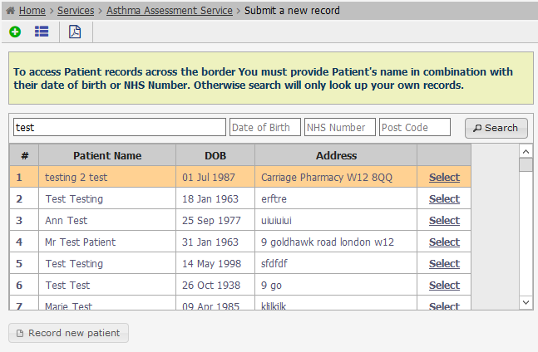

- Enter name, surname or DOB and click on ‘Search’ button
- Select the patient from the search results panel

  - Record a new patient

- Click on ‘record new patient’ button
- Enter patient details (Name, surname, DOB, etc.) – All mandatory information is marked with (*)
- Click on ‘Save personal details’
- If all information is correct a confirmation message will be displayed.

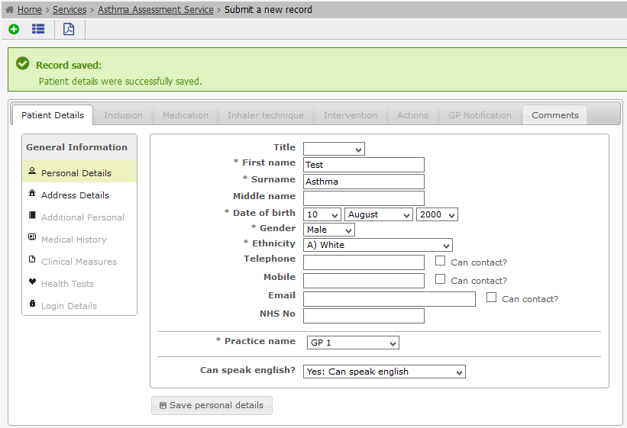
Confirmation of success

- Enter address details

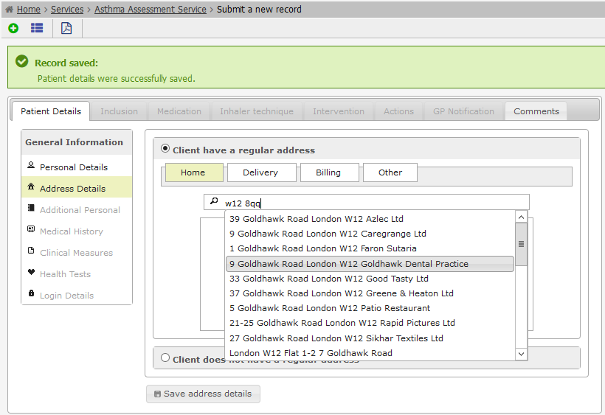
Type the post code
and select address
from the list
  - Inclusion

- Answer the RCP (Royal College of Physicians) questionnaire
- Once all questions have been answered, the score and the explanation of the result will show up in a new window.
- Click on ‘Continue with service’ button

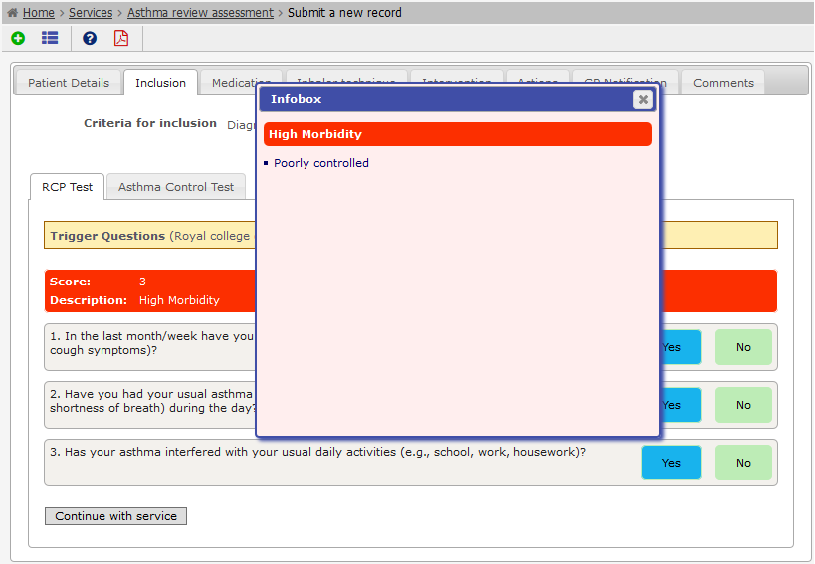
Answers
Information box
Score and
Description

- Answer the Asthma Control Test (system will show either Child or Adult test, depending on the age of the patient)
- Once all questions have been answered, the score and the explanation of the result will show up in a new window.
- Click on ‘Continue with service’ button

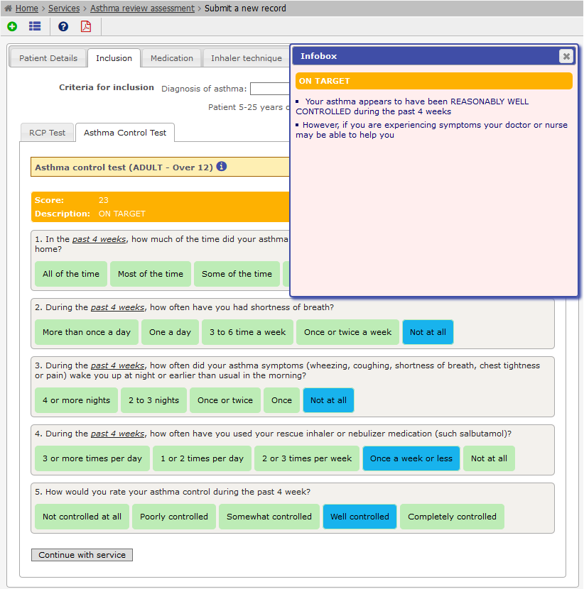
Answers
Score and
Description
Information box

  - Add medication

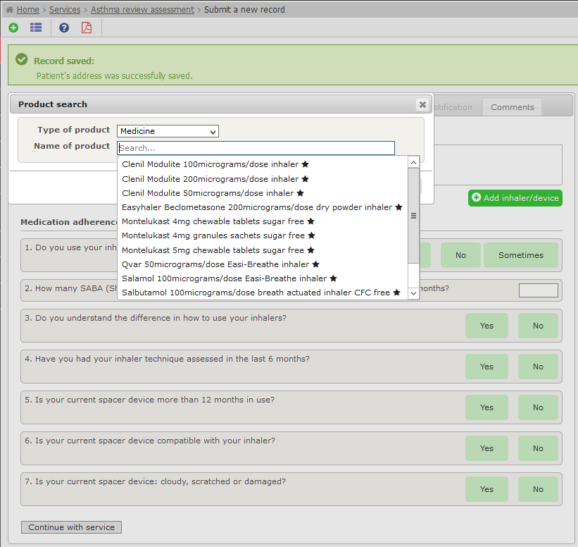
Select a medicine
Add medicine

- Click on ‘Add inhaler/device’ button
- From the popup window, select the medicine
- Answer medication adherence questionnaire

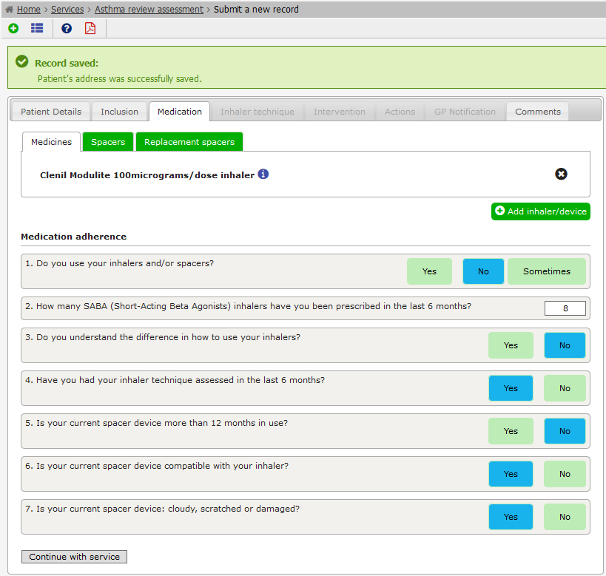

Medication Adherence
Questionnaire
Product Video
Product Infobox

  - Inhaler technique

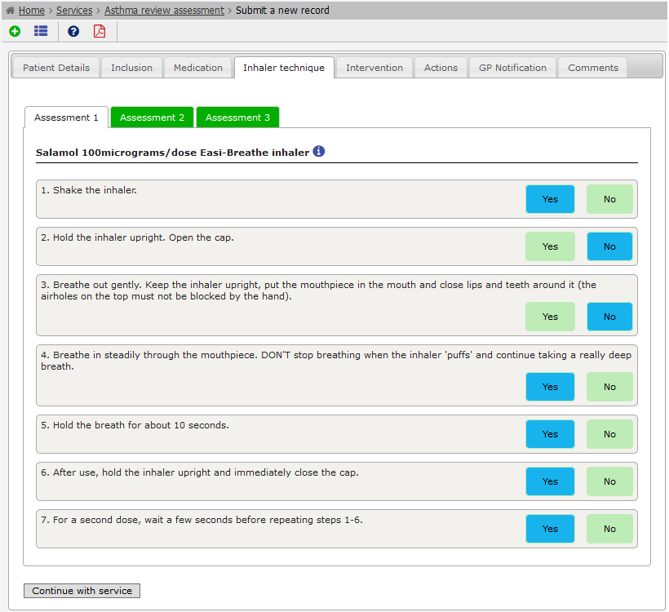
Inhaler Technique Questionnaire

  - Intervention

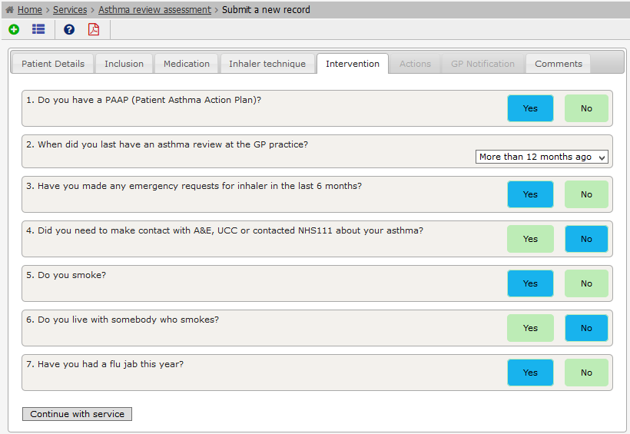

Intervention Questionnaire

  - Actions

- Decide whether the patient requires an urgent referral.
- Fill in any additional information

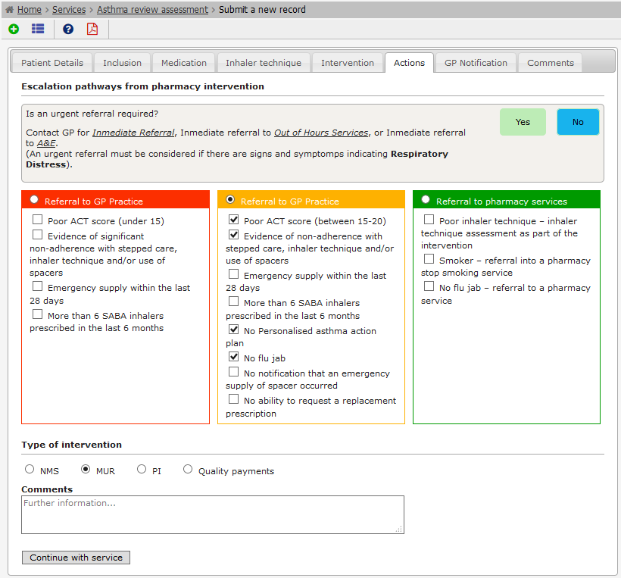
Type of Referral
Urgent
Non urgent
Escalation pathways

  - GP Notification

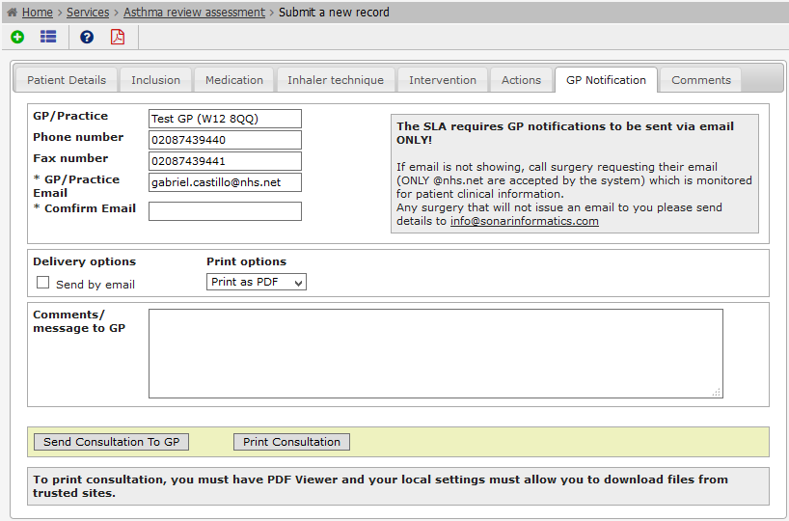
Print GP Notification
Send Notification to GP

  - Sample GP Notification

