Guidance on writing an effective policy to promote positive mental health and wellbeing in schools and colleges

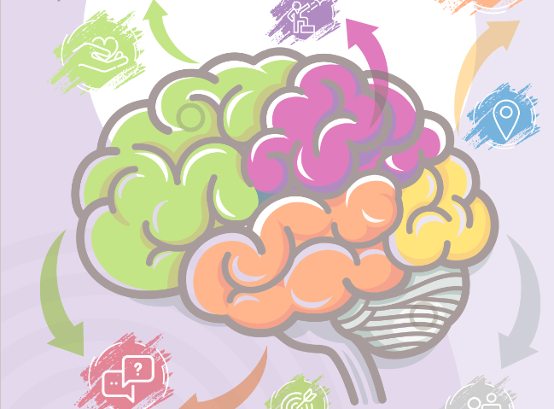

Introduction
In an average classroom, three children will be suffering from a diagnosable mental health condition. Schools, and colleges play a vital role in promoting positive emotional wellbeing, identifying mental health needs at an early stage, referring young people to specialist support, and working jointly with others to support young people experiencing problems.
Currently, there is no duty for schools to have a separate mental health policy, however there are duties on schools to promote and protect the welfare of their pupils, as set out by Government guidance, ‘Keeping children safe in education’. There are also duties on schools to ensure pupils with additional educational needs, including those in relation to mental health, are provided with adequate support to learn, as set out in, ‘Special educational needs and disability code of practice: 0-25 years’. Given the recognition of the importance of mental health and wellbeing in schools and the focus provided by the recent Mental Health Green Paper, the Government will revisit the question of whether it should be a statutory requirement for schools to publish a distinct mental health/wellbeing policy.
Health education is to be made compulsory in all schools in England from 2020 as part of the Relationships Education, Relationships and Sex Education and
Health Education (England) Regulations 2019 requirements. Draft guidance states that teachers should be clear that mental wellbeing is a normal part of daily life, in the same way as physical health.

The Mental Health and Wellbeing Policy should form part of the whole school approach to emotional health wellbeing and resilience.

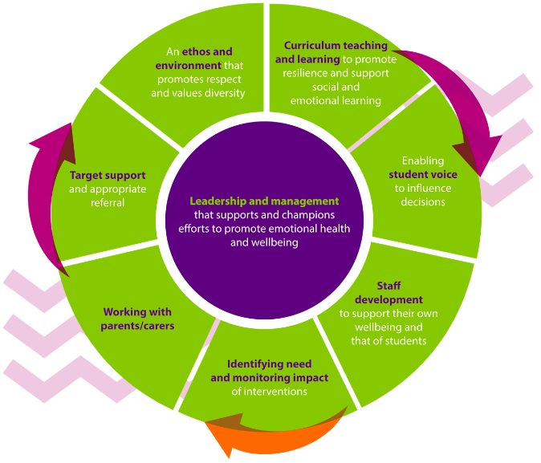

This guidance document aims to support schools and colleges to write effective procedures and policies for promoting positive mental health and wellbeing, that meet the needs of their school community.

Background

By developing and implementing practical, relevant and effective mental health policies and procedures schools can promote a safe and stable environment for everyone in the school community as well as helping the many pupils affected both directly and indirectly by mental ill health.

The school has an important role to play, acting as a source of support and information for both pupils and parents. A well-developed and implemented policy can prevent pupils from falling through the gaps.

Tips for writing a Mental Health and Wellbeing policy

Keep it practical
A lengthy policy is less likely to be read and implemented than a shorter policy.

One way to cut down on the length of policy is to make it a ‘doing’ document and to develop separate sources of information which can be attached as appendices or held on the school’s virtual learning environment.

Keep it simple
Using diagrams, or a simple flowchart might be helpful.

Avoid the use of overly complicated language and technical terms or jargon. Write the policy in language that can be understood by everyone from the most experienced to the least.

Learn from past experience
A good starting point for writing the policy is to reflect on what has worked well and less well in the past. When put into the context of a real pupil, the policy and procedures will make more sense and it will be easier to see any gaps, which need to be addressed.

Draw on pupil and parent voices
Seeking input from the school’s pupil council, holding a focus group or sending out an anonymous questionnaire can be a good way to understand pupils’ experiences and opinions.

Drawing on the experiences of parents or pupils who are ready to share, especially those whose children have faced or are facing mental ill health, can also be helpful.

Consider seeking input from parents and pupils both in the early stages of policy development and also later on when there is a draft policy to share that they might feedback on.

Outline warning signs
Highlighting some key warning signs within the context of the school setting can be very helpful to staff and ensure that alarm bells ring at the right time.

Make it clear what to do next
The policy needs to be clear on what staff should do with such concerns. All concerns, however minor, should be followed up in line with school policies and procedures. (Please note, the school/college emotional wellbeing action pathway is shown in the template policy below and may be helpful for this section).

Name key members of staff
All parties need to know exactly who is responsible for what and how they should communicate concerns or queries with key members of staff.
As a minimum, names need to be provided for the school’s/college’s:

- Designated child protection / safeguarding officer
- Staff Emotional Wellbeing Lead
- Lead first aider
- Pastoral lead
- CPD lead in case people need training

It is important to keep the policy up-to-date with any staff changes and to clearly communicate these changes to all staff.

Have a plan for disseminating your policy
It is important to share the policy with colleagues, governors, pupils and parents.

Some ideas might include:

- Adding the policy as an agenda item for discussion at the next governing board meeting
- Introducing the policy as part of a twilight session
- Printing off copies of the policy for staff to browse in the staff room
- Emailing a copy or direct link to the policy to all staff
- Sharing salient points from the policy with pupils via PSHE or tutor periods
- Putting the policy on your public facing school website
- Highlighting the new policy as a news item or blog post on your website
- Sharing your new policy in a newsletter with parents
- Including information about the policy as part of all new staff induction

Good communication of the policy will bring the additional benefit of bringing the topic of mental health to the fore and getting pupils, staff and parents talking about it.

Signpost support
The school’s policy on promoting mental health is a key place to signpost relevant sources of support available via the school.

Give clear guidance about confidentiality
It’s important that the policy is clear on disclosures – when they should and should not be kept confidential. Schools/colleges will have different guidelines on this.

Review and update your policy regularly
Remember to build in a date to review and update the policy and procedures. It is recommended that this is carried out yearly. Ideally, it will be an evolving document which reflects the developing best practice in the school/college as it develops, as part of the whole school/college approach. The policy should always be instantly updated when named people change.

Share best practice with other schools
Working with colleagues in similar schools/colleges or within clusters can be helpful to share ideas and experiences.

START OF EXAMPLE POLICY

Mental Health and Wellbeing Policy example

Promoting positive mental health and wellbeing in XXXX school/college policy

Date of document: xxx 2019
Date for review: xxx
Lead reviewer: xxx
Approval by: xxx Governing body

School/College Name

Mental Health is a state of well-being in which every individual realises his or her own potential, can cope with the normal stresses of life, can work productively and fruitfully and is able to make a contribution to his or her community. (World Health Organisation).

At xxx school/college, we aim to promote positive mental health and wellbeing for every pupil and member of staff. We pursue this aim using a whole school approach to Emotional Health Wellbeing and Resilience.

In addition to promoting positive mental health and wellbeing, we aim to recognise and respond to mental ill health. In an average classroom three children will be suffering from a diagnosable mental health issue. By developing and implementing practical, relevant and effective mental health policies and procedures we can promote a safe and stable environment for pupils affected both directly and indirectly by mental ill health.

Scope

This document describes the school’s approach to promoting positive mental health and well-being. This policy is intended as guidance for all staff including non-teaching staff and governors.

This policy should be read in conjunction with our medical policy in cases where a pupil’s mental health overlaps with or is linked to a medical issue and the SEND policy where a pupil has an identified special educational need.

The policy aims to:

- Promote positive mental health and wellbeing in all staff and pupils
- Increase understanding and awareness of common mental health issues
- Alert staff to early warning signs of mental ill health
- Provide support to staff working with young people with mental health issues
- Provide support to pupils suffering mental ill health and their peers and parents or carers

Lead members of staff

Whilst all staff have a responsibility to promote the mental health of pupils, staff with a specific, relevant remit include:

- Xxxx – designated child protection/safeguarding lead
- Xxxx – designated safeguarding governor
- Xxxx – designated mental health and wellbeing lead
- Xxxx – designated mental health and wellbeing governor
- Xxxx – lead first aider
- Xxxx – pastoral lead
- Xxxx – Continuous Professional Development (CPD) lead
- Xxxx – Head of PSHE
- Xxxx – Lead Emotional Wellbeing Governor
- Xxxx – Named School Nurse

Any member of staff who is concerned about the mental health or wellbeing of child or young person will speak to our designated mental health and wellbeing lead in the first instance. If there is a fear that the child or young person is in danger of immediate harm then the normal child protection procedures will be followed with an immediate referral to our designated safeguarding lead, Headteacher or the Central Bedfordshire Multi-Agency Safeguarding Hub (MASH). If the pupil presents a medical emergency then the normal procedures for medical emergencies will be followed, including alerting the first aid staff and contacting the emergency services if necessary.
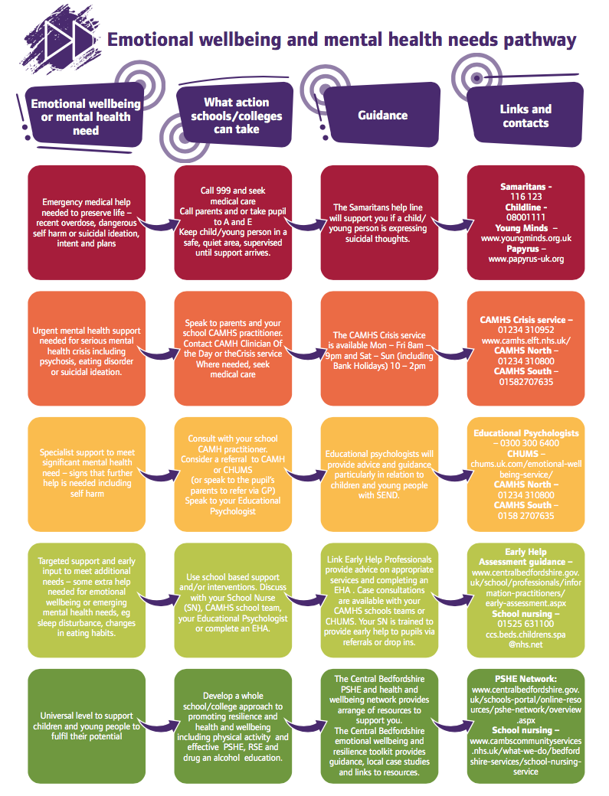
Where a referral to CAMHS is appropriate, this will be led and managed by our mental health and wellbeing designated lead XXXX. Guidance about referring into Bedfordshire CAMHS (October 2018) is provided below.

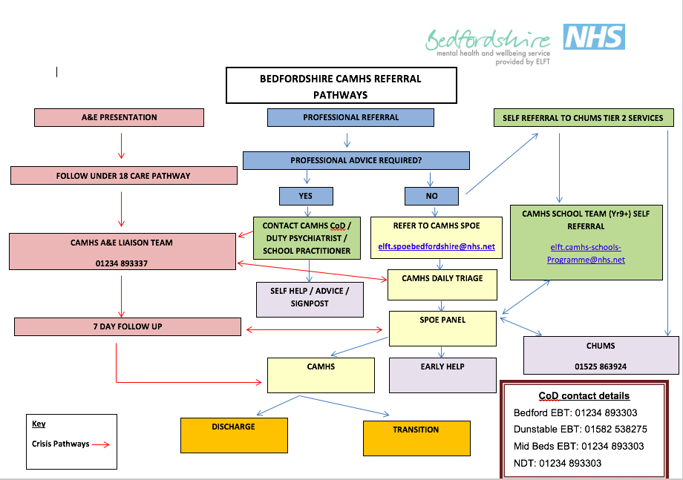

Individual care plans

We will draw up an individual care plan for pupils causing concern or who receive a diagnosis pertaining to their mental health. This will be drawn up involving the pupil, the parents and relevant health professionals. This may include:

- Details of a pupil’s condition
- Special requirements and precautions
- Medication and any side effects
- What to do and who to contact in an emergency
- The role the school can play

Teaching about mental health

The skills, knowledge and understanding needed by our pupils to keep themselves and others physically and mentally healthy and safe are included as part of our developmental PSHE curriculum, as part of our whole school/college approach.

The specific content of lessons will be determined by the specific needs of the cohort being taught but there will always be an emphasis on enabling pupils to develop the skills, knowledge, understanding, language and confidence to seek help, as needed, for themselves or others.

We will follow the PSHE Association Guidance to ensure that we teach mental health and emotional well-being issues in a safe and sensitive manner which helps rather than harms. We will plan for and deliver statutory mental health education as set out by Government Regulations effective from 2020.

Signposting

We will ensure that staff, pupils and parents are aware of sources of support within school and in the local community. What support is available within our school and local community, who it is aimed at and how to access it.

We will display relevant sources of support in communal areas such as common rooms and toilets and provide relevant links on our school/ college webpage. We will regularly highlight sources of support to pupils within relevant parts of the curriculum. Whenever we highlight sources of support, we will increase the chance of pupils seeking help by ensuring pupils understand:

  - What help is available
  - Who it is aimed at
  - How to access it
  - Why to access it
  - What is likely to happen next

Warning signs

There are often warning signs which indicate a child or young person is experiencing mental health or emotional well-being issues. These warning signs are taken seriously and staff observing any of them should communicate their concerns with xxxx, our Emotional Wellbeing lead. While not exhaustive, the list below details possible warning signs as follows:

Secondary pupils
- Physical signs of harm that are repeated or appear non-accidental
- Changes in eating or sleeping habits
- Increased isolation from friends or family, becoming socially withdrawn
- Changes in activity and mood
- Lowering of academic achievement
- Becoming socially withdrawn
- Talking or joking about self-harm or suicide
- Abusing drugs or alcohol
- Expressing feelings of failure, uselessness or loss of hope
- Changes in clothing – e.g. long sleeves in warm weather
- Secretive behaviour
- Skipping PE or getting changed secretively
- Lateness to or absence from school
- Repeated physical pain or nausea with no evident cause
- An increase in lateness or absenteeism

Primary pupils
- Unusual play (in playground)
- Unusual drawings (in class)
- Tendency to isolate themselves
- Compulsive lying
- Attention seeking
- Repeated physical pain or nausea with no evident cause
- Pulling hair out (self-harm)
- Hurting other children
- No empathy
- Anxiety
- Hiding inside clothes (making self invisible)
- Loud and disruptive
- Hiding lunch
- Over/under eating
- Soiling

Managing disclosures

A child or young person may choose to disclose concerns about themselves or a friend/sibling to any member of staff, so all staff have been briefed/trained on how to respond appropriately to a disclosure.

If a pupil chooses to disclose concerns about their own mental health or that of a friend/sibling to a member of staff, the member of staff’s response will always be calm, supportive and non-judgemental.

Staff will listen rather than advise and the focus should be of the child or young person’s emotional and physical safety rather than of exploring ‘why?’

All disclosures will be recorded in writing and held on the child or young person’s confidential file. This written record will include:

- Date of disclosure
- The name of the member of staff to whom the disclosure was made
- Details of the full conversation with the child and adult, where relevant
- Agreed next steps

This information will be shared with the designated Emotional Wellbeing Lead xxx who will store the record appropriately and offer support and advice about next steps.

Confidentiality

Staff will be honest with regard to the issue of confidentiality. If it is necessary to pass on concerns about a child or young person, then they will discuss with the child or young person:

- Who they are going to talk to
- What they are going to tell them
- Why they need to tell them

Information about a child or young person will not be shared without first telling them. Ideally their consent will be received, though there are certain situations when information will always be shared with another member of staff and/or a parent, for example if the child is in danger of harm.

We will always share disclosures with a colleague, usually the Emotional Wellbeing Lead xxxx. This helps to safeguard the emotional well-being of the member of staff as they are no longer solely responsible for the pupil. It also ensures continuity of care in the absence of that member of staff and provides an extra source of ideas and support. This will be explained and discussed with the pupil along with who it would be most appropriate and helpful to share this information with.

Parents will always be informed if pupils are in danger of harm and/ or XXX , however children or young people may choose to tell their parents themselves. If this is the case and there are no concerns about the child’s imminent safety, the child or young person will be given 24 hours to share this information before we contact the parents.

We will always give a child or young person the option of us informing a parent for them or with them. We will provide a contact point for parents if they have further questions and will arrange a meeting or phone call as parents often have many questions.

Each meeting will finish with agreed next steps and a brief record of the meeting will be kept on the child’s confidential record.

If a child gives us reason to believe that there may be underlying child protection issues, parents will not be informed, but the Designated Safeguarding Lead xxxx must be informed immediately.

Training

As a minimum, all staff will receive annual training about recognising and responding to mental health issues to enable them to keep child or young person safe. Relevant staff will attend the CHUMS Early intervention school training programme.

Training opportunities for staff requiring more in-depth knowledge will be considered as part of a whole school approach to emotional wellbeing and the school’s performance management process. Additional CPD will be supported throughout the year where it becomes appropriate.

Policy Review

This policy will be reviewed every year. It is next due for review in Month Year.

Additionally, this policy will be reviewed and updated as appropriate on an ad hoc basis. If you have a question or suggestion about improving this policy, this should be addressed to xxxx via phone xxxx or email xxxx.

This policy will always be immediately updated to reflect personnel changes.

Further sources of information

Central Bedfordshire Local Safeguarding Children Board website
The Central Bedfordshire PSHE/Health and Wellbeing Network webpages provide a range of resources for schools on mental health and wellbeing
The Charlie Waller Trust May 2017 Guidance on how to write a mental health a wellbeing policy for schools and colleges.

END OF EXAMPLE POLICY

References

Public Health England (2016) The mental health of children and young people in England. Available online at: https://assets.publishing.service.gov.uk/government/uploads/system/uploads/attachment_data/file/575632/Mental_health_of_children_in_England.pdf
Department for Education (2015) Keeping children safe in education. Statutory guidance for schools and colleges on safeguarding children and safer recruitment. Available online at: https://www.google.com/search?q=Keeping+children+safe+in+education’&ie=utf-8&oe=utf-8
Department for Education (2014) SEND code of practice: 0 to 25 years Guidance on the special educational needs and disability (SEND) system for children and young people aged 0 to 25, from 1 September 2014. Available online at: https://www.gov.uk/government/publications/send-code-of-practice-0-to-25
Department for Education (2018) Relationships Education, Relationships and Sex Education (RSE) and Health Education Guidance for governing bodies, proprietors, head teachers, principals, senior leadership teams, teachers. Draft for consultation. Available online at: https://consult.education.gov.uk/pshe/relationships-education-rse-health-education/supporting_documents/20170718_%20Draft%20guidance%20for%20consultation.pdf ^{iii}The Charlie Waller Trust May 2017 Guidance on how to write a mental health a wellbeing policy for schools and colleges. Contact us… by telephone: 0300 300 7409 by email: customers@centralbedfordshire.gov.uk on the web: www.centralbedfordshire.gov.uk Write to Central Bedfordshire Council, Priory House, Monks Walk, Chicksands, Shefford, Bedfordshire SG17 5TQ

